Quick guide - Filling the «Form for statistical classification of programmes/projects»

General information
When filling in the form, please make sure the form includes information for the complete agreement period with Norad. The form must also be in accordance with the agreement with Norad and approved budget. For Norad’s systems to successfully import the forms, do not format/code cells or columns.

Each row represents the organisation’s/network’s “subunit”: a breakdown and more detailed information about each programme and/or project according to sectors and sub-sectors. How each programme is coded, depends on its nature and/or arrangement.

A programme can be coded as a single subunit or be divided into several subunits. For instance, if a programme has several components, it should be divided into several subunits e.g.:
- If a school project consists of educating teachers (DAC code 111.30) and access to elementary school (DAC code 112.20), the programme should be divided into two separate subunits.
- If a programme has activities in several countries, then it should also be divided into several subunits.
- It is not necessary to create a separate subunit for each implementing partner. It is sufficient to list the largest implementing partner for each subunit and then give information on the other partners in the application form and the sub-agreement description.
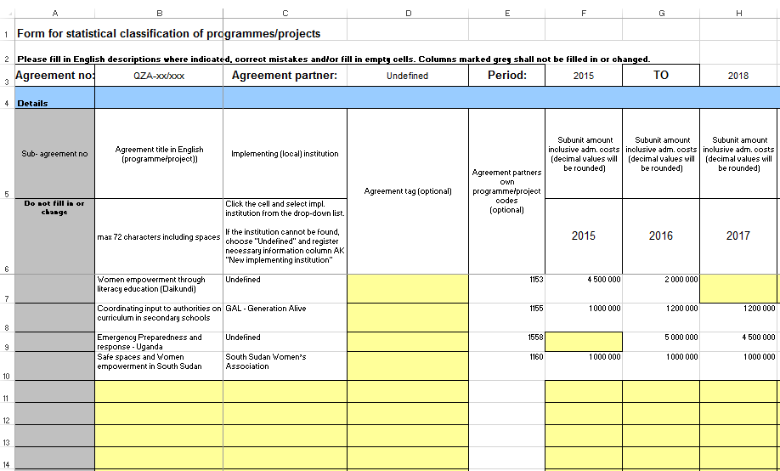
Figure 1 – An outline of Norad’s form. Each row represents one subunit .The form must include information about the agreement’s programmes and budget for the complete period.

Filling out the form for statistical classification of programmes and projects
The information to be filled in is mainly based on definitions agreed on by the OECD/DAC (Development Assistance Committee). For information about the categories and choices available, please use Norad's Statistical Classification Manual. The information is publically available here: https://norad.no/statisticsmanual.

Please note
- New statistical coding is introduced to track the Covid-19 related effort in Norwegian development assistance. For guidance we refer to the dedicated information on this topic (attached in email), which will also be included in the Statistical Manual. But please note that for agreements adversely affected by the pandemic, but not actively addressing it or its consequences, no marking of the Focus area: Covid-19 is warranted.
- Agreement title: maximum number of characters has been increased to 150.
- Agreement description: maximum number of characters has been increased to 2000.

Details
- Sub agreement no: The agreement numbers are automatically generated by Norad’s systems. Therefore, do not edit this column.
- Agreement title: Must be in English. Do not exceed 150 characters. Titles should be precise and informative. Avoid the use of abbreviations and colloquialisms/idioms.
  - Examples of titles that should be avoided:
    - UN-REDD
    - PSE/TIPH HOM
    - Amendment no 4
  - Examples of good titles:
    - STEPS – Climate Change Impact – enhancing capacity of women
    - Learning from REDD+: Enhanced global comparative analysis
- Implementing (local) institution: Click on the cell and select the right implementing (local) institution from the drop-down list. If the institution cannot be found, choose "Undefined" and register the necessary information under column AK "New implementing institution". Use the institution’s full name. Avoid abbreviations.
- Agreement tag (optional): For programmes that fit one of the agreement tags from the drop-down list. If several of the options are applicable, choose the most fitting tag. If none of the tags fit, leave the cell empty.
- Agreement partners own programme/project codes (optional): Can be used if the organisation or network wishes to use its own internal codes. Will not be used for statistical purposes or made available for others.
- Subunit amount inclusive adm. costs (decimals will be rounded): Totals must include administrative costs and be in accordance with approved budget/sum granted. Sums must be in Norwegian kroners (NOK). Avoid decimals and formatting/coding (e.g. =SUM( ) or =F7+G7+H7) when filling in the form.
- Sub-agreement period (4 digits): Fill in the first year and planned exit year under the present agreement. E.g., if the agreement runs from 2015-2017, then the planned exit year should not exceed 2017.
- Sub-agreement description in English (Max 2000 characters including spaces. All text for the same programme/project in the same cell. Description is reported to OECD/DAC): As the title indicates, the descriptions are reported to the OECD/DAC. As with the agreement titles, the descriptions should give accurate and precise information about each programme. Descriptions must be in English. Avoid abbreviations. Do not exceed 2000 characters.
  - Example of description that should be avoided:
    - Mapping public employees

Statistical classifications
- DAC- sector 3 & 2 digits Statistical manual gives more information in English regarding DAC sectors: See Norad’s Statistical Classification Manual, Appendix 1 for more information (pages 39-62).
- Recipient country: See Norad’s Statistical Classification Manual, Appendix 3 for more information (pages 64-66).
- Form of assistance: The design and nature of the cooperation between the Norwegian government/Norad and cooperation/agreement partner. See Norad’s Statistical Classification Manual for more information (pages 7-10).
- Policy marker (choose 0, 1 or 2 for relevant policy markers) Statistical manual gives more information in English regarding policy markers: See Norad’s Statistical Classification Manual for more information (pages 13-32).
- Focus areas (choose 0 or 1 for relevant focus areas) Statistical manual gives more information in English regarding focus areas: See Norad’s Statistical Classification Manual for more information (pages 33-34).

Other information
- Type of assistance: Automatically classified by Norad. Therefore, do not edit this column.
- New Implementing institution: For implementing institutions marked “Undefined” (ref. paragraph about “Implementing (local) institution”). Fill in the name of the new implementing institution according to the guidelines.
- Local institution: Not to be filled out.
- GPS coordinates: Not to be filled out.

