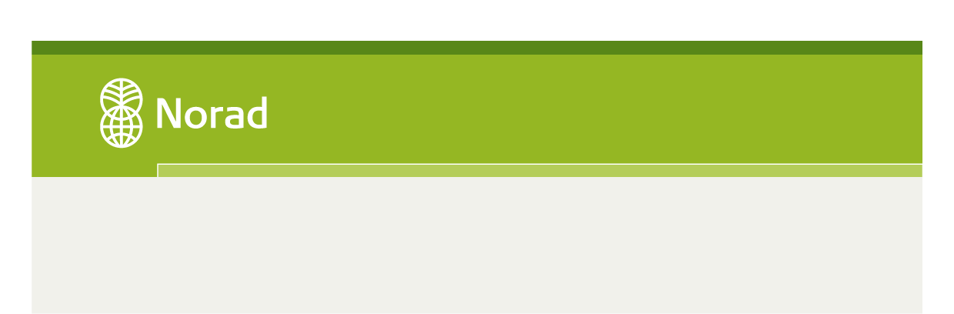
PROJECT SUMMARY, APPLICATION FOR FUNDS FOR THE FOLLOW UP OF SCR 1325 2015-2017
Name of applicant:
Place of registration/main office:
Legal status:

Project title:
Duration of project/application period:
Goal of project (impact):
Geographic focus:
Main working method/activity profile:
Relevant thematic goal for application:
How the project will contribute towards the thematic goal:

1.Peace processes and peace negotiations Goal: Both women and men are included in peace processes, and peace agreements include the needs and priorities of both women and men 2. Peace building in post conflict contexts Goal: Womens’ political and economic rights and participation is strengthened in post conflict contexts and political transitions

