REDD Exchange Results Bar

Transparency International (TI)

Project Title:

PAC REDD: Civil Society Capacity Building for Preventative Anti-Corruption Measures in REDD

Project Summary:

Preventative Anti-Corruption Measures (PAC) REDD was born of TI’s concern that, left unchallenged, corruption and fraud could significantly undermine the effectiveness of REDD+. Strengthening anti-corruption through improved transparency and accountability contribute toward ensuring robust governance to enable the environmental and social benefits which REDD+ aims to achieve. Through mutually reinforcing research, advocacy, networking and capacity building activities, TI has diagnosed risks and finding solutions in Indonesia, Papua New Guinea, Vietnam, as well as on the international stage. This work comes at a critical time in the formulation of REDD+ policy and the piloting of projects. TI has established itself as a go-to for advice on the creation, enforcement and monitoring of anti-corruption safeguards, and the furthering of transparency, accountability and citizen engagement in REDD+.

Project Information:

The PAC REDD project budget was NOK 12 million from June 2010 to August 2013, implemented globally (by TI’s international secretariat) and in Indonesia (by TI Indonesia), Papua New Guinea (by TI Papua New Guinea (TI PNG)), and Vietnam (by Toward Transparency Vietnam (TT)). This is one of three projects under TI’s Climate Finance Integrity Programme, funded by the Norwegian Agency for Development Cooperation (NORAD). Funding for this work will continue through 2013-2015. These national chapters were selected on the strength of their work on forest governance in previous years, and the reputation and networks that this has lent them.

PAC REDD is aimed at ensuring that REDD+ meets its intended objectives through the adoption of transparency and accountability initiatives by relevant government agencies, private sector organisations and financial institutions, and having a civil society capable of monitoring integrity in REDD+ mechanisms. The project has engaged all REDD+ stakeholder groups, with a special emphasis on collaboration with civil society organisations (CSOs) engaged with forest law enforcement, governance, and/ or trade in the project countries. Project activities included:

- Training CSOs and the media on anti-corruption for REDD+, along with targeted actions regarding the private sector to push for transparency and accountability.
- Development of a methodology to assess corruption risks in REDD+ through stakeholder consultation and the publication of the risk assessment manual, Keeping REDD+ Clean.
- Advocacy interventions at all levels, including a REDD+ integrity campaign and local, national, and regional conferences to discuss relevant anti-corruption tools and best practices.

Project Justification:

Addressing corruption risks proactively, now

Many of the world’s most densely forested countries have a poor track record for corruption. Politicians have been known to accept bribes – sometimes huge – to grant companies access to forest zones that should be protected. Meanwhile, some local communities have been forcefully removed from their homes in order to clear the way for forest exploitation.

REDD+ will inherit many of the corruption risks that have long beset the forestry sector, but it also brings with it new ones. Carbon is intangible, and so difficult to quantify. This opens the door to mistakes or manipulation – both of data and of people. Given the remoteness of REDD+ sites there may be no easy way of knowing whether a project is authentic or bogus. And forest communities may be marginalised from decision-making and profits.

PAC REDD takes a preventative approach to corruption in REDD+. TI national chapters in Indonesia, Papua New Guinea and Vietnam have been analysing risks, and devising tailor-made strategies to mitigate them before corruption sets in. Programme staff are working with governments, CSOs, communities and companies to design and implant safeguards that – through enhanced transparency, accountability and citizen engagement – narrow entry points for corruption in REDD+, hereby reducing the financial, environmental and social losses that it threatens.

Dedi Haryadi is PAC REDD Team Leader at TI Indonesia.

“Indonesia’s forests are often used as a resource to fuel party politics. In the mid-1990s the Ministry of Forestry reportedly took US$600 million from the country’s Reforestation Fund and invested it in projects that were more politically favourable. Forest land and proceeds are also an important source of party political financing, and can be used to buy votes and secure support. The more informed people are about corruption risks, the more likely it is that we can keep these threats in check. We are working across all sections of society to build anti-corruption skills, policies and support.”
Affecting broad-
based change

Project Results:

Corruption comes in a number of guises, and is endlessly creative. Countering it requires careful time spent up-front to establish the processes, institutions and practices that are most vulnerable to abuse. The initial months of PAC REDD were spent developing a step-by-step manual for assessing and prioritising risks to REDD+ effectiveness. Keeping REDD+ clean walks users through how corruption can take root at all stages, from policy-making in the capital to projects deep within the forest. It provides a simple yet comprehensive framework for examining a country’s policy, legal, regulatory and institutional governance as pertains to REDD+, assessing and prioritising corruption risks according to the likelihood of occurrence and the severity of potential damage wrought, and addressing those risks preemptively.

The manual offered TI national chapters far more than a research methodology - it was an entry point for them to meet with relevant parties across the REDD+ landscape, offering a practical means of broaching sensitive issues and structuring conversations around positive, preventative actions. The guide has been used extensively within the project countries, and has been well-received by international audiences. GIZ, for example, have expressed an interest in co-developing a similar document for use on FLEG-T.

Rick Jacobsen is Team Leader of International Forest Policy at Global Witness.
“Transparency International’s new guide to preventing corruption in REDD+ can help governments, the private sector and NGOs to address old and new risks at the national level. Talking about corruption in many of the countries participating in REDD+ isn’t easy; often it’s the large and menacing elephant in the room. But the best way to begin addressing these risks is to shed light on them, as Transparency International’s guide ably does.”

REDD-affected communities were one of the key stakeholder groups with whom chapters conducted consultations. During the diagnostic phase of the project staff visited a number of REDD+ pilot sites, to gauge locals’ levels of awareness of REDD+ and to question them on the extent of their involvement in the development of REDD+ systems. One trip taken by TI PNG provided the inspiration for a regional-wide educational campaign on REDD+ risks and opportunities.

The village of Leileiyafa is located on one of five REDD+ pilot sites in PNG, in the southern province of Milne Bay. TI PNG had arrived there equipped with leaflets detailing their work on REDD+. Much of the village’s population was illiterate, however, so TI PNG tried instead to communicate the fundamentals by drawing pictures. These were the first in a long line of sketches that were to culminate in a campaign poster – aimed at piquing people’s interest in REDD+ opportunities and risks, and connecting them to local sources of advice. The poster presents alternative scenarios – what happens when REDD+ works, and what happens when corruption creeps in - and has a box for chapters to include their contact details and those of their local partners. This has been translated into local languages in all three countries and will be rolled out to REDD-affected communities in September.

Elements from the REDD+ integrity campaign poster

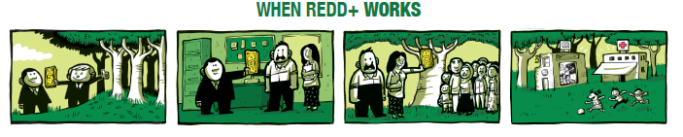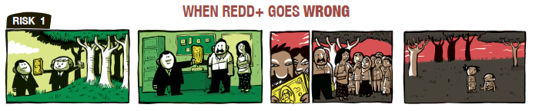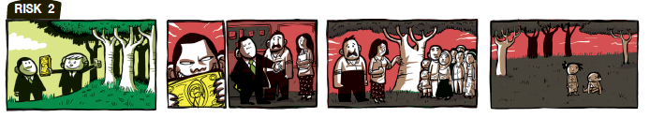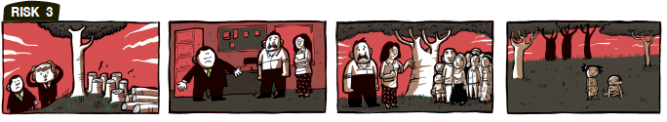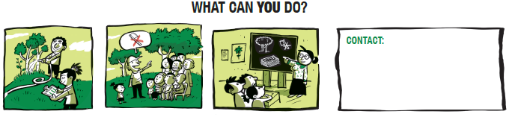

Back in PNG, the chapter organised a meeting between the Forest Authority and landowners in Leileiyafa and surrounding villages to discuss the mechanics of REDD+ and future steps in the region. This opened up key lines of communication that were previously lacking, and will be further monitored by the chapter. The PAC REDD team are also building the capacity of their Advocacy and Legal Advice Centre to receive and process complaints related to REDD+. The centre offers free and confidential advice to victims and witnesses of corruption, and offers solid cases study evident to support anti-corruption advocacy across the country.

The TI team in Vietnam, Towards Transparency (TT) are active at the local level also, piloting REDD+ project monitoring tools in the province of Lam Dong. In this instance, however, the chapter was requested to do so by their government. This signals a phenomenal shift in discourse since the PAC REDD project began, when the relevant ministries refused to admit that corruption posed a threat to REDD’s success, and took a far more obstructionist approach to TT Vietnam’s work. Civil society occupies an extremely limited space in Vietnam. The approach of constructive engagement pursued by TT Vietnam in the early phases of the project succeeded in forging a number of key strategic relationships with government that have been pivotal for achieving PAC REDD’s aims. They were granted a seat on the task force elected to develop Vietnam’s National REDD+ Strategy and Action Plan. Their influence in this forum is demonstrated by the fact that both documents now contain language suggested by TT Vietnam aimed at strengthening governance provisions for REDD+ in policy and practice.

Progress on REDD+ has been more sluggish in Indonesia, but the team there continue to play a key watchdog role over nascent policies and institutions. The ministries of Forestry and Agriculture recently announced their commitment to becoming official Integrity/ Corruption-Free Zones. Keen to ensure that this is not an exercise in window-dressing, TI Indonesia are advising the ministries on how to translate their pledges to a robust programme of action. REDD+ finance monitoring is also a key priority for the chapter as the project enters its second phase. PAC REDD has been staunchly advocating for sounder governance arrangements in the country’s new Fund for REDD+ Indonesia (FREDDI), and have constructed a community of practice around monitoring the fund’s activities, with a dedicated Facebook page for knowledge exchange. The chapter then channels this data upwards, to KPK (the Corruption Eradication Commission) and the National REDD Task Force, with whom they have regular and frank dialogue on the current and next steps for REDD+ in the country.

These experiences in-country have provided an important cache of case studies of good and bad practice that TI has used in its advocacy efforts on the international stage – showcased at the Conference of Parties, and a series of capacity building events organized by, for example, UN-REDD/UNDP, EU FLEGT, CIFOR and GIZ. The Keeping REDD+ clean manual in particular has received good exposure in international forums and online. This has helped TI galvanise support and input from international partner organisations, which has in turn strengthened knowledge exchange and relationship-building in the three project countries.

Lessons learned:

Looking back to move forward

At TI’s recent Climate Finance Integrity Talk in Bangkok, a panelist from Indonesia’s REDD+ Task Force commented on the important convening role that TI Indonesia is playing in the country. The chapter brought together a broad mix of REDD-relevant groups for a series of workshops on Indonesia’s National REDD+ Strategy. Had it not been for TI Indonesia’s mediating role, said the Task Force representative, participants would not have felt comfortable openly articulating their criticism and concerns, which allowed the Task Force to reorient their strategic direction accordingly.

Throughout the course of the PAC REDD project the team has come to realise where its input is most valuable – at the intersection of policy-makers and grassroots organisations that might otherwise go unheard in decision-making fora. The challenge in achieving this mediating role has been to gain buy-in and support across all sectors of society, and to facilitate situations in which all groups talk openly and constructively about a highly complex issue – REDD+ – and a highly sensitive one – corruption. To do this staff have learned to tailor their messaging so that it resonates at all levels.

Moving ahead, the PAC REDD team is aware of the need to leverage the standing they have gained in REDD+ circles to shift the gear from problem understanding to problem solving. It has become clear that governments may lack the capacity or the motivation to carry out the tasks required of them to strengthen anti-corruption provisions in REDD+. In such instances, TI will seek to provide technical and practical assistance to close the gap – TT Vietnam will prioritise project monitoring tools, TI Indonesia financial oversight, and TI PNG forest community consultations.

All three chapters have struggled to adequately engage the private sector, in large because of the unwillingness of companies to enter into dialogue. Given the level of influence the private sector is likely to have over REDD+ TI chapters will in the coming months devise a strategy for convincing private actors of the merits of corruption prevention. One tool they are planning to employ is TI’s Integrity Pact – an agreement signed during a public procurement tender between government agencies and bidders that they will refrain from bribery and other forms of corruption. Companies have often been very keen on these pacts, which have created a level playing field that would otherwise be lacking. The pacts have also proven a good entry point for co-developing with companies integrity policies and monitoring and enforcement procedures for their operations.

Developing and strengthening anti-corruption project monitoring and citizen hotlines are two fundamental areas where TI clearly plays important roles to support REDD+ actions. These roles are filling gaps as REDD+ and climate finance governance more broadly still struggle with questions of accountability and law enforcement in many recipient countries. TI continues to support positive policy changes while taking on actions to promote anti-corruption until reforms happen. When things go wrong, TI - through early-warning approaches will also be better situated to prevent damages and demand accountability.

As TI’s Climate Finance Integrity Programme grows to work globally, sharing experiences and know-how becomes extremely important and relevant. Connecting TI’s teams in, for example, Cameroon, Indonesia and Mexico will benefit the development and advocacy for innovative policy changes and actions for monitoring implementation over time. National level knowledge also will be brought more proactively in international policy dialogues to ensure coherent approaches are in place and working.

Contact:

Lisa Elges, Team Leader, Climate Finance Integrity Programme
lelges@transparency.org

