Norad evaluation department

Has Norwegian aid included persons with disabilities?
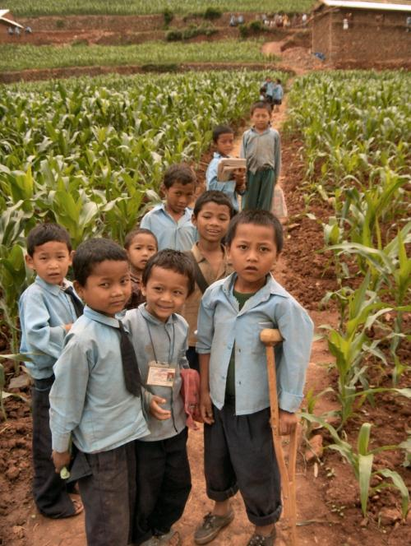
Picture of children going to school in Nepal, ©Save the Children

Easy Read Paper

Has Norwegian aid included persons with disabilities?
This is an easy read paper of the evaluation report:
Mainstreaming disability in the new development paradigm
Evaluation of Norwegian support to promote the rights of persons with disabilities
Report 1/2012 Evaluation
This evaluation includes also country studies from four countries, Uganda, Nepal, Malawi and the Palestinian territory.
You will find the reports on http://www.norad.no/no/resultater/publikasjoner

Norad
Norwegian Agency for Development Cooperation
P.O.Box 8034 Dep, NO-0030 Oslo
Ruseløkkveien 26, Oslo, Norway
Tel: +47 23 98 00 00 Fax: +47 23 98 00 99
postmottak@norad.no
www.norad.no
ISBN 978-82-7548-637-8

Has Norwegian aid included persons with disabilities?

Background
There are many hundreds of millions persons with disabilities in the world. Most of them are very poor. They are not given the chance to go to school. They do not have a job. They do not get health services and social services. Many are isolated. Often they are not welcomed by their family and the community. Women and girls often suffer from violence and sexual abuse.

Norway wanted to do something about this bad situation. In 1999 the parliament decided that all aid projects should include persons with disabilities. The office in Norway that was responsible for the aid is called Norad. Norad made instructions to the ministeries, embassies and organisations and explained how to include persons with disabilities.

Norway also worked with the United Nations to make an international law for persons with disabilities. The new law is called the Convention on the Rights of Persons with Disabilities. It was adopted in 2008. So far 110 countries have promised to follow this law. Norway has still not promised.

In 2010, Norad wanted to find out if the Norwegian development aid had made life better for persons with disabilities. Norad asked consultants to help. The consultants came from Norway, Uganda, Palestine, Malawi and Nepal. The consultants read documents and statistics. They talked to people in these five countries. Totally they asked more than 350 persons about their opinion. They talked especially to persons with disabilities to find out if their lives had been better.

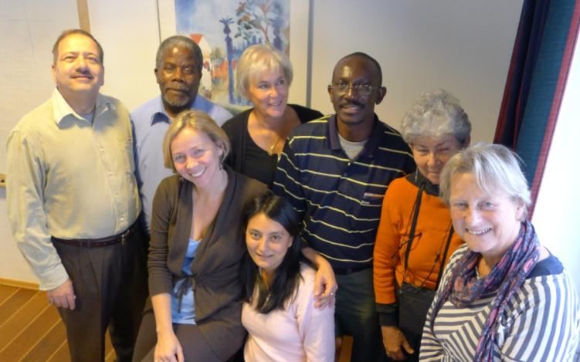
All the consultants met in Oslo to write the reports (photo: Trude Bang/NCG)

What did we find out?

The consultants found out that too little had changed since 1999. Nobody knew about the instructions from Norad, except Atlas Alliance. Atlas Alliance is a group of disability organisations in Norway. They work together to better the lives of persons with disabilities in other countries.

The support to persons with disabilities continued to be small. For every 100 dollars Norway spent on aid to poor countries, only 50 cent was for persons with disabilities. This means around 22 million dollars per year. The support also continued to be separated from the other aid projects. However, some of this small Norwegian support showed good results:
- Organisations of persons with disabilities had become bigger and more influential.
- Partner countries had adopted better laws for persons with disabilities.
- Individuals had been helped by medical and rehabilitation projects.
- Community-based programs helped many people get in contact with health, education and social services.
- Victims of land mine explosions received medical treatment and help to find jobs. Many of the land mine victims are active in organisations. Their voices are heard in United Nations conferences.

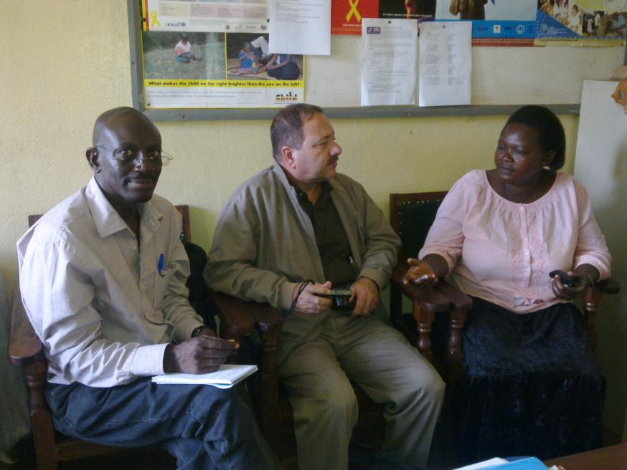
Betty Busiku, (Visually impaired) says that her life was changed thanks to the Community-Based Rehabilitation project (CBR) in Uganda. She is now a CBR volunteer, women’s rights activist, and a sign language interpreter. In the photo she is talking to the consultants. CBR projects support persons with disabilities to be included in society and to get services (photo: Basil Kandyomunda).
The consultants found that most of the disability projects focussed on persons with physical impairments. Persons with developmental disabilities and those with hearing impairments were the last to be reached.

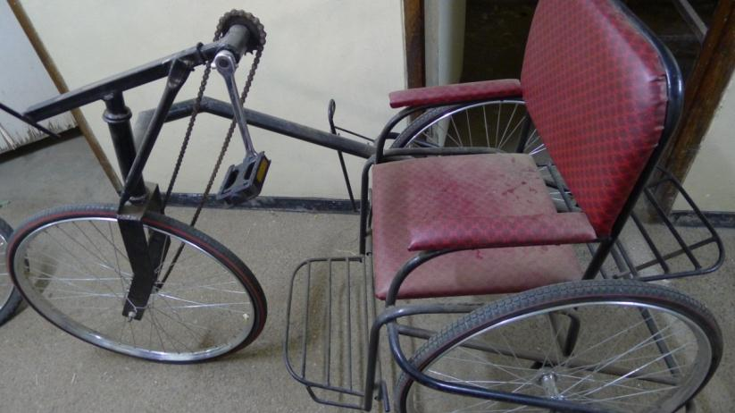
Picture from a workshop in Malawi where they make tricycles, artificial limbs and other things that help persons with difficulties in walking (Malawi Council of the Handicapped, MACOHA)(photo: Nora Ingdal/NCG).

Persons with disabilities were included in very few general aid projects. But some have tried. The best examples were:
- The World Bank tried to influence their staff and projects to consider persons with disabilities.
- The education programs in Nepal and Palestine tried to reach children with disabilities. In Palestine, Norway paid for new schools to be built with ramps. In Nepal Norway paid for grants to students with disabilities.
- The health program in Malawi built new hospitals with ramps.
- The humanitarian projects in Uganda tried to help persons with disabilities in the conflict areas.
- Plan Norway tried to include children with disabilities in community programs.

The results from these general programs are still small and not well documented. Nobody knows exactly how much money has been used for inclusion of persons with disabilities.

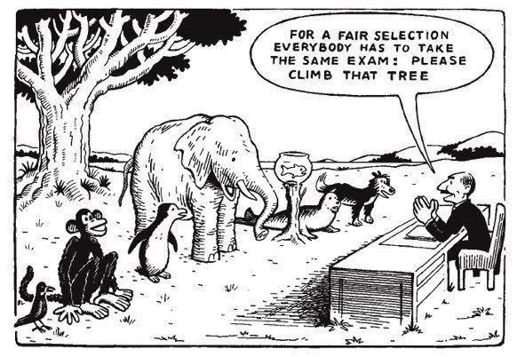
This is how some people understand inclusion of persons with disabilities. The teacher treats every animal in the same way. This is not fair, because the animals have different abilities. Inclusion should be about adapting teaching and exams to each learner. (Cartoon from India).

The reasons for not including persons with disabilities are:
- Decision makers think that other issues are more important.
- They think it is difficult and expensive to include persons with disabilities.
- They do not understand that poverty reduction will not happen unless persons with disabilities are included.
- They think that disability is a medical and individual problem that should be solved by “fixing” the persons with a disability.
- They do not recognise that barriers in society are the main obstacle.
- The disability organisations have failed to change the decisions of the Embassies, Norad and the organisations.

The consultants also found out that women and girls with disabilities did not get enough support. Many organisations forgot to include them in their projects. To defend their rights women with disabilities had created their own organisations.

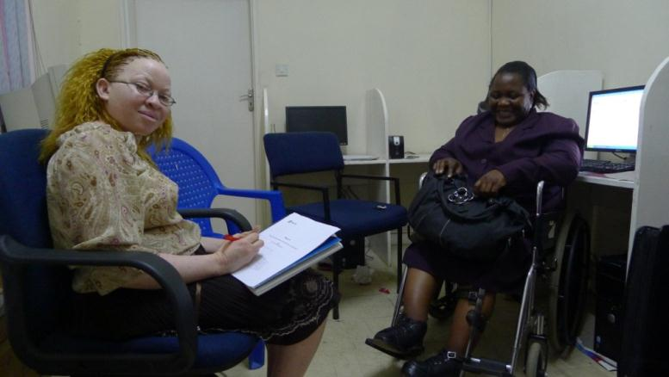
In Malawi the women organisation is called DIWODE. Here is a photo of Sigele Kasasi and Pamela Juma (photo Nora Ingdal/NCG).

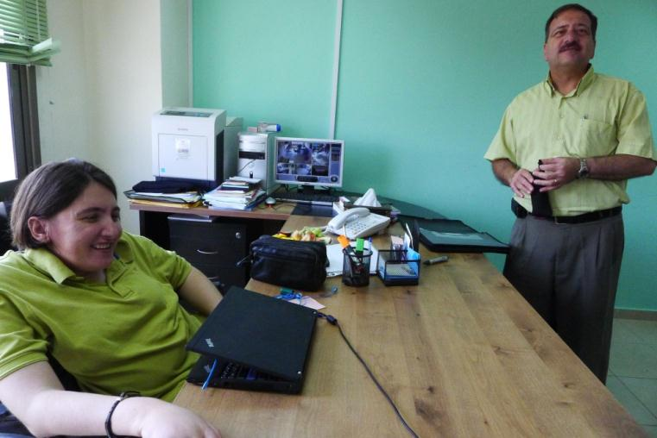
In Palestine women with disabilities’ organisation is called Stars of Hope.
Here is a photo of Ola Abu Ghaib being interviewed by the Palestinian lead consultant Dr Malek Qutteina (photo: Nora Ingdal/NCG).

What could be done?

The consultants recommend that:
- Norwegian politicians should decide and tell everybody that persons with disabilities must be included in all development aid and humanitarian programs. The new international law (the Convention) requires this.
- Norway has a good model for including gender equality in aid programs. Norway should use the same model to include persons with disabilities.
- Every aid program should explain how it will include men, women and children with disabilities.
- Every aid program should report how they have changed the lives of men, women and children with disabilities.
- Aid programs for persons with disabilities should also be checked by persons with disabilities.
- More money should be given to disability in aid programs. This money should be reserved especially for inclusion of persons with disabilities.
- Education programs need to become better.
  - Norway should demand that they include children with all types of disabilities.
  - Norway should demand that they give teachers better training
  - Norway should also give more money to education programs. At least 15 NOK for every 100 NOK (15%) should go to education programs.
- More money should be given to the Atlas Alliance. They must work better to convince and guide decision makers and other organisations to include persons with disabilities.
- Persons with developmental disabilities and persons with hearing impairment should receive extra attention and support.
- Norway should work together with other countries to achieve more. For example the other Nordic countries, Australia and USA.

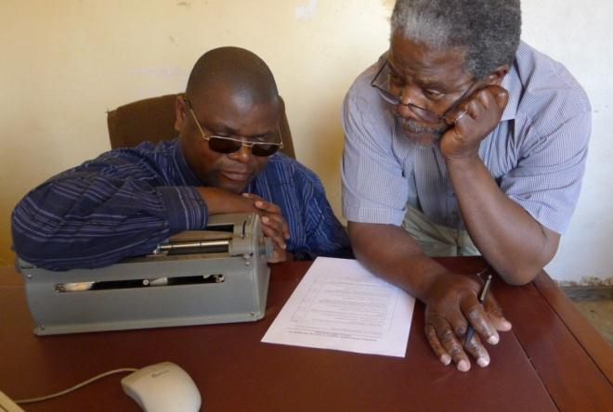
The head of the Malawi Union of the Blind was interviewed by
the lead consultant in Malawi, Jack Makoko. Here is a photo of Jack reading some questions to Ezekiel Kumwenda (photo: Nora Ingdal/NCG).

