**Theory of Change (ToC) for the Norad portfolio on civic space [April 2025]**

**Why have a portfolio on civic space?**

Civic space is what enables individuals and civil society organizations to organize, participate, and communicate freely to influence political and social structures. It encompasses legal, policy, institutional, and practical conditions that protect fundamental human rights, including freedom of expression, peaceful assembly, and association.  Civic space is defined as the combination of these civil and political rights and the state’s duty to protect these universal freedoms.[1] Human rights legislation places the responsibility to protect civic space on the state, and a functioning civic space, i.e. a space where states effectively protect these freedoms, is a prerequisite for civil society to exercise its independent role.

Support to civil society is central to enhancing development, human rights and democracy and to counter shrinking civic space. Civil society is “*… an arena where people come together to promote interests and needs on behalf of themselves and others, challenge power-holders, and influence political debates. Civil society includes formally registered organisations, informal grassroots organisations and social movements*”.[2] This definition does not exclude anti-democratic civil society actors. Further, civil society may be fragmented, reflecting social and societal divides and polarisation. Nevertheless, a vibrant civil society is considered central for advancing sustainable and inclusive development, human rights and democracy, as well as upholding civic space. Although there are several contextual nuances, evidence shows that development cooperation directed towards civil society, freedom of expression and human rights has shown positive effects on democratization[3]. In accordance with Norad’s Guiding Principles for support to civil society, actors to be supported are those who further the objectives of democratisation, poverty eradication, human rights and sustainable development.

Nonetheless, globally, civil and political rights are under threat. Civic freedoms are in decline. The world has seen increased autocratisation[4] since the early 2000s. While established democracies are becoming less democratic, authoritarian states are becoming more authoritarian. During the past five years, there has been a significant global increase in restrictions on the freedom of peaceful assembly and other constraints on civil society's operational space. This is also prevalent in some Western democracies, where civil society may face verbal, physical, legal, and financial attacks[5]. Particularly authoritarian governments impose restrictive laws targeting civil society organizations, such as foreign agent laws, bans on foreign funding, and excessive bureaucratic requirements. Such laws delegitimize and constrain civil society activities[6]. The anti-terrorism agenda, including anti-terror financing legislation, is also used to exert control over civil society[7]. During the COVID-19 pandemic, civil society further experienced practical and economic challenges, coinciding with government-imposed restrictions on gatherings and protests. Authorities in several countries enhanced control and surveillance of civil society, often retaining such measures post-pandemic. Authoritarian regimes use digital technologies for surveillance, disinformation and to create polarization. Digital tools are also used by civil society actors, however, to access and spread information and mobilise communities. Positively, the last decade has also seen an increase in pro-democratic civic action[8], often constituted by informal civil society like social movements.

**What will Norad contribute to?**

The portfolio will address the problem of shrinking civic space. The overarching objective, on an impact level, is to enhance the ability of civil society organisations to hold governments accountable so that civic space is respected and protected. Within the framework of the portfolio, Norad will offer partners the flexibility to adapt to changing contexts and needs, enhancing their readiness to act on windows of opportunities. Additionally, many (all?) of Norad’s other portfolios support civil society actors. The synergies between portfolios will help underscore and enrich the work of the civic space portfolio.

The medium-term objective is that civil society can influence national laws and policies as well as international normative processes on civic space. Many states have legal and policy frameworks in place that in theory protects civic space, but lack necessary implementation., Hence, a longer-term outcome is that laws, policies, and implementation at the national level protect civic space.

*How?*

Norad’s efforts will focus on funding, information dissemination and dialogue through three different change pathways. The portfolio will aim at interventions both at the global level and at country level primarily towards countries relevant to Norwegian development cooperation.

*The three change pathways leading towards the outcomes:*

1. **Coordination, collaboration, and coalitions for civic influence:** By enhancing cooperation, coalition-building and exchange, civil society will be better placed to influence political processes to protect and enhance civic space. Norad will support coalition-building within civil society[9] and with allies like independent media and academic institutions nationally and internationally. In some contexts, the judicial sector can be an important ally. The aim is to deepen, broaden and sustain coordination, collaboration, and coalitions to protect and enhance civic space.[10]
2. **Digital civic space:** By ensuring civil society has the ability and support mechanisms both to protect themselves and each other in the digital space[11] , they will be able to use digital tools effectively to spread information, reshape narratives and mobilise to protect civic space. Norad will support the development of digital protection mechanisms and capacity building.
3. **Knowledge production, learning and sharing:** By enhancing knowledge production, learning, cooperation and exchange, donors can ensure more targeted and effective support to protect and enhance civic space and strengthen civil society in ODA countries. Norad will support civil society in learning from each other’s experiences nationally and internationally, so that strategies and tactics are based on knowledge of what works best to protect civic space in different contexts.

*Why?*

The global non-profit Civicus[12] classifies civic space as either open, narrowed, obstructed, repressed or closed[13]. Norad will prioritise interventions in narrowed, obstructed or repressed countries, based on an assumption that to be effective, civil society organisations depend on a certain degree of room to manoeuvre to further enhance civic space. Although relevant, support to civil society organisations in countries categorised as closed is expected to be less effective in reaching the objectives of this portfolio.

**The assumption is that certain enabling factors** help enhance civic space and are thus cross-cutting priorities for the portfolio:

1. Locally lead development and shifting power dynamics will enhance the role of local actors in identifying the issues, strategies and tactics to be deployed at country level. As international connections and work at the normative level also are crucial, the aim for the Norad support is to be locally led and globally connected.
2. Linking formal civil society with informal civil society actors like activists, youth groups and social movements is key to foster a more inclusive approach and ensure representation and engagement.

**How will the interventions contribute to goal achievement?**

Learning and sharing of experiences

The portfolio has three different partner levels: while the three change pathways are not specifically linked to either one, the intervention areas will somewhat differ between the three.

At the **spearhead level**, Norad funds international NGOs focusing on civic space and civic freedoms, and work on **knowledge and data**-gathering on civic space.

These organisations have experience facilitating CSO participation at the international level and credibility to **advocate** globally. They will serve as the engine of the change process, testing new and innovative models for protecting and enhancing civic space, work on experience sharing and learning, and focus on facilitation and coordination of the work to influence the global normative agenda.

The global work will both be influenced by and feed into the **advocacy work** and **policy reforms** at the national level. **Coalition-building** between civil society, media and academic institutions will be crucial.

At the **mid-level,** the focus will mainly be on financial support, strategic dialogue and exchange of experiences and lessons learned with Norwegian partner organisations working on strengthening civil society in ODA countries.

The **bottom level** includes support to and facilitation of civil society in ODA countries[14], including networking and coalition-building, that contributes to enhancing civil society legitimacy and engagement. Agreements at this level are not directly part of the portfolio but may be used to gather experiences and lessons learned on a country level, also contributing to **knowledge production and sharing**.

**Knowledge and data** on current trends of democracy and civic space is well documented.[15] However, there is a need for increased knowledge on what works best in different contexts, as well as to create spaces for CSOs to share and learn from each other. The portfolio will enable Norad to gain more knowledge and experience on relevant issues, as outlined in the knowledge plan for the portfolio. The specific sequencing of interventions will vary, depending on the country contexts. We will also connect other portfolios to these partner levels, where relevant. We know that there are several civil society organisations working with all three change pathways and towards the same outcomes within other thematic portfolios in Norad, and when there is an identified link, we will connect them to the ongoing sharing of knowledge and learning within this portfolio.

While Norad’s contributions and civil society’s work aim at (in the long run) strengthened advocacy and, ultimately, the three long-term goals, the results on the impact level goal of an enhanced and protected civic space will vary depending on several factors, such as whether:

* *Global normative processes influence national governments*
* *International actors give civil society access to influence policy and politics*
* *Civil society has legitimacy and accountability: “The legitimacy of a civil society actor is linked to the degree to which other stakeholders perceive their actions as being both justifiable and appropriate [ … ]. The accountability of civil society actors refers to their willingness and ability to answer to, and take responsibility for, their actions, activities and messages”[16]*
* *Coordinated efforts by civil society and allies will help shift incentives among political elites and increase political will to protect civic space*
* *National civil society sets aside competition and collaborate actively*
* *Civil society utilizes knowledge and lessons on how to best protect and enhance space*

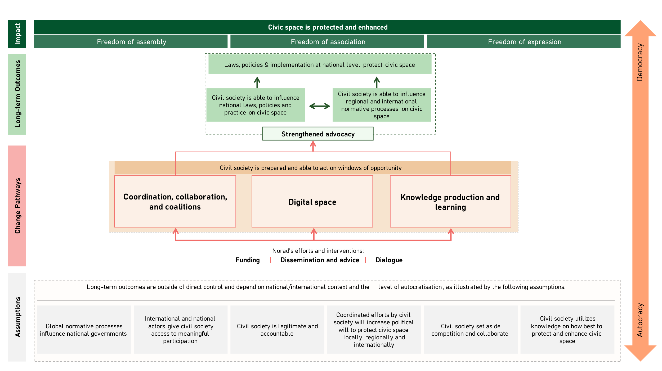

1. [Civic space | OECD](https://www.oecd.org/en/topics/sub-issues/open-government-and-citizen-participation/civic-space.html): «the set of conditions non-governmental actors need to participate in public life”
2. We base our definition of civil society on [NORAD’S SUPPORT TO CIVIL SOCIETY: GUIDING PRINCIPLES](https://www.norad.no/contentassets/396cdc788c09405490a96adce80ac040/norads-support-to-civil-society-guiding-principles.pdf)
3. [Effekter av svenskt och internationellt demokratibistånd | EBA](https://eba.se/rapporter/effekter-av-svenskt-och-internationellt-demokratibistand/12550/)
4. As reported by [V-Dem](https://www.v-dem.net/), [Freedom House](https://freedomhouse.org/sites/default/files/2023-03/FIW_World_2023_DigtalPDF.pdf) and the Economist Intelligence Unit’s [Democracy Index.](https://pages.eiu.com/rs/753-RIQ-438/images/DI-final-version-report.pdf?mkt_tok=NzUzLVJJUS00MzgAAAGKO5hDKqC-tynVk0400lk_f3gvFB8dqBggJ0t50zWtQiwaqU6Q169ylDZusO6oetYSdzX8bOl54ztW_dasPqUvT3xC4lj4y8SUU3ygvdzj_PMqDg)
5. the Liberties Law Report 2025
6. [A New Wave of Repression on Civic Space](https://europeandemocracyhub.epd.eu/a-new-wave-of-repression-on-civic-space/)
7. Governments have referred to The Financial Action Task Force (FATF) Standards of 40 recommendations, when passing draconian anti-terror financing legislation, and especially recommendation number 8.
8. Danish MFA, [Study of Danish Support to Informally organised Civil Society and Social Movements in Developing Countries](https://um.dk/en/danida/results/eval/eval_reports/study-on-danish-support-to-informally), July 2021, published September 2021.
9. Including between the more established formal civil society and informal civil society like activists and social movements.
10. [ICNL Report from the African regional workshop on Protecting Civic Space,](https://www.icnl.org/wp-content/uploads/our-work_Africa-Regional-Workshop-on-Protecting-Civic-Space---Final-Report.pdf) 2014, University of Pretoria as quoted in Westminster Foundation for Democracy (WFD), [Addressing the global emergency of shrinking civic space and how to reclaim it: a programming guide,](https://www.wfd.org/what-we-do/resources/addressing-global-emergency-shrinking-civic-space-and-how-reclaim-it) December 2020.
11. This includes protection from different threats like surveillance, theft and misuse of sensitive data, targeted disinformation, and deep fakes that discredit and attacks civil society and civic leaders, with women and minority groups often being targeted the most.
12. [Home (civicus.org)](https://www.civicus.org/)
13. [Civicus Monitor](https://monitor.civicus.org/globalfindings/)
14. [ODA recipients: countries, territories, and international organisations | OECD](https://www.oecd.org/en/topics/sub-issues/oda-eligibility-and-conditions/dac-list-of-oda-recipients.html)
15. V-Dem, Freedom House, the Economist Intelligence Units and Civicus Monitor.
16. [NORAD’S SUPPORT TO CIVIL SOCIETY: GUIDING PRINCIPLES](https://www.norad.no/contentassets/396cdc788c09405490a96adce80ac040/norads-support-to-civil-society-guiding-principles.pdf), pages 7-8