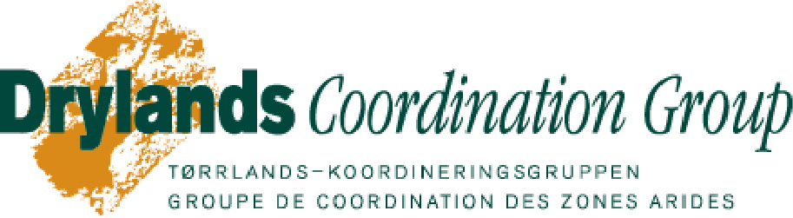

DCG Presentation at NORAD seminar on women and humanitarian aid – November 1st 2006
1. Brief presentation of the Drylands Coordination Group (DCG):
- DCG is a network of NGOs, governmental bodies and research institutions. We do not have operational activities, but we conduct studies in rural drylands of Africa, we share the results of our studies at seminars, we organize training workshops, and we engage in advocacy and lobbying activities. Our main focus is food security.
- We work in the rural drylands of four countries in Africa: Eritrea, Ethiopia, Mali and Sudan.
- Our work related to women: we have not, in the past, focused very specifically on women in our research but we do have a few studies dealing specifically with women. However, gender is included in our new strategy (2007-2011), in our values/ working principles: we emphasize gender equality and we promote gender sensitivity in our activities. We thus plan to conduct more studies in the future on women and gender issues.

2 Women in dryland areas:
Women play important roles in drylands in preserving knowledge, food, fuel and shelter. They are affected differently than men by phenomena such as desertification (which is land degradation in dryland areas) since they have different roles as producers. When land degradation and drought occur, women will have to travel longer distances to fetch wood and water increasing their workload. The agricultural production level will also decrease leading to less food and income. Women in drylands are often left behind by their husbands who migrate or die in conflicts. When they then become heads of households, women and their families become more vulnerable as their workload increases and they are forced to adopt men’s chores without however benefiting from the same access to financial, technical, and social resources. Women are also more vulnerable as they are often given the more marginal and degraded lands for their production.

Women are not able to access development/ extension services on an equal basis with men due to several factors, such as: illiteracy, cultural restrictions, shortage of free time, gender biases in institutions, etc. There is also a lack of diversification of development options for women (focus on micro-finance and rarely training provided in agricultural technologies) and a lack of female extension agents. Empowerment of women in terms of decision-making and changes in access rights to land and water are also essential for reducing poverty in rural drylands. Finally, development policies need to include gender issues and in general be more gender sensitive.

There is a need to specifically target women in development interventions. Not only are women often excluded from development projects and agricultural extension work, but often policies and development plans ignore their needs and interests. It is not enough to just include women in projects, but their needs and opinions need to be taken into consideration already from the planning phase of the intervention in order for projects to effectively target and help/ reach women. Women have the possibility of becoming participants and not just indirect beneficiaries if the project is gender sensitive and includes women from the beginning on. Two examples from our work strengthen this remark.

3. Example from Tigray, Ethiopia: Study on livelihood interventions and Female Headed Households (FHH):
- The study included a short overview of the practical implications of some policies and development interventions for women and FHHs in particular.
- The study looked at the different livelihood options of FHHs compared to Male Headed Households (MHHs) especially based on their ownership and access to resources and how they are able to use these resources.
- It was found that women in FHH had better literacy rates, more access to information on e.g. women’s rights, better economic empowerment, more decision-making power, and smaller family sizes. However, FHHs owned fewer assets and spent less annually. This lack of assets made FHHs more vulnerable to shocks such as drought (e.g. they lacked cattle that they could sell in times of crises as a coping strategy). FHHs also lack labour which forces them to enter into share-cropping agreements with men and to diversify their activities.
- The study also looked at the household oriented food security package program which is a government led program that provides agricultural credit and training in Tigray, Ethiopia. The aim of the study was to better understand how the program was being perceived by and benefiting FHHs.
- The study found that MHHs benefited more from the program than FFHs as it e.g. required intensive labour which the FHHs could not provide. (MHHs benefited more from the program as they could engage in different labour demanding activities). On the other hand, women in MHHs were rarely trained and received little information about the program (only through their husbands).
- It was thus recommended (main conclusion), that a package program should be designed that specifically targets FHHs and that would then take into consideration their capacities (e.g. for physical work and also their assets and access to tools e.g.). FHHs should also be provided with technical support and different and adequate training programs.
- Other studies show that women more readily adapt technologies if these are adapted to the tasks they perform and also if the extension agent is a women or if other women demonstrate the technologies.

Note: We were just informed that a new separate extension package program is being designed for women at the Federal level in Ethiopia. The findings and recommendations of the report are being incorporated in this new separate package program for women.

4. Example from Mali: The Ecofarm approach:
- The Ecofarm concept is a strategy to generate technologies that will reduce poverty through increased production at the farm level while at the same time preserving the environment. It focuses on strengthening the interaction between different components of the farm. Furthermore, it is based on the belief that the combination of scientific knowledge and farmer knowledge will lead to sustainable development. The participating farmers will have at their disposition a ‘basket of options’ from which they will be able to choose elements that would be useful for their farm and possible to implement.
- It is a participatory approach; farmers are involved in designing and testing the technologies that fit them. Farmers are trained in technologies.
- The project has been very successful in Mali and is now being implemented in Ethiopia and will soon start in Sudan. A clear example of its success is that farmers not originally involved in the project (from neighbouring villages) started adopting technologies themselves.
- However, a major lesson learned is that women did not benefit equally from this project as they were less trained than men. This is not only a problem of inclusion but mostly of targeting. For women to be interested in taking part in this training and then adopting the technology, their needs have to be addressed. Thus, the training and the technologies must address crops that they are responsible for/ interested in cultivating such as peanuts for example which they can then sell and make an alternative income out of (which is a coping strategy). The activities presented during the training should then be interesting for women. Thus, there is a need to specifically target women in development projects and not just include them as if they had the same interests and practiced the same activities as men.

5. Conclusion:
Based on our studies we see the need for short and long term development interventions to not only include women but especially to specifically target them. Interventions should then be developed and designed with women so that these are adapted to their interests, capacities and needs. This will require training in gender sensitivity for development and governmental institutions in general, as well as for extension agents (both women and men). Given the important role of women in development in general, they should be given the possibility to sustain, improve, and adapt coping strategies for their survival and that of their families and communities especially in the face of long-term threats such as land degradation or global climate change in dryland areas.

For more information on these projects and a copy of the Female Headed Household report, please visit our website: www.drylands-group.org

Sources:

Desta, M., Haddis, G., Ataklt, S. 2006. DCG Report 44: “Female-Headed Households and Livelihood Intervention in Four Selected Weredas in Tigray, Ethiopia.”. Drylands Coordination Group, Miljøhuset G9, Norway. Available at: http://www.drylands-group.org/Articles/810.html

IFAD, 2006. “Gender and desertification. Expanding roles for women to restore drylands.” http://www.ifad.org/pub/gender/desert/gender_desert.pdf

UNEP, 2005. “Chapter four: Women and desertification: a dynamic relationship”
http://www.unep.org/PDF/Women/ChapterFour.pdf

