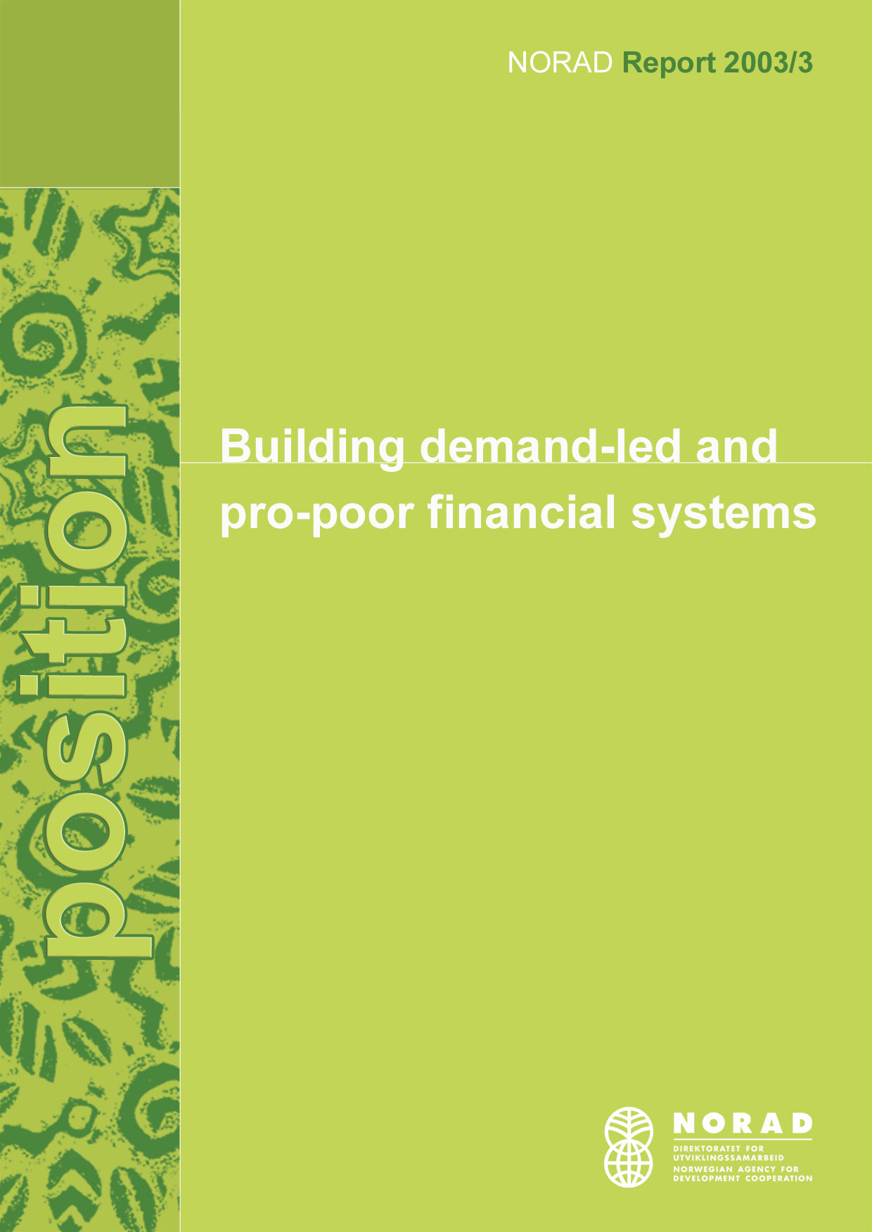

SUMMARY

What is microfinance?
- Microfinance is provision of a broad range of client-responsive financial services (loans, savings, insurance) to poor people through a wide variety of institutions.
- Microfinance includes urban microfinance, rural finance through cooperatives, credit schemes to small-scale fisheries, and credit components in larger projects such as integrated rural development projects.
- As of June 2002, NORAD, The Ministry of Foreign Affairs (MFA), Norfund and 13 Norwegian NGOs were involved in microfinance activities, with a total of 160 projects.

NORAD intends to:
- Continue working through Norwegian NGOs.
- Advocate a pro-poor financial system approach and follow international good practices and principles.
- Promote pro-poor innovations in close cooperation with other donors.
- If working directly with MFIs, cooperate closely with other donors at the country level.
- Maintain the excellent coordination and exchange of information between Norwegian actors.
- Continue to be active within CGAP and advocate social aspects of microfinance.

Why microfinance?
- Financial services for the poor can be a powerful tool for poverty reduction by enhancing the ability of poor people to increase incomes, build assets, and reduce vulnerability in times of economic stress.
- Microfinance fits well into Norwegian development cooperation's rights-based approach to poverty reduction and private sector development.
- The vision of building permanent pro-poor financial systems through donor coordination and harmonisation is coherent with the principles behind new development cooperation practices.

How to promote pro-poor financial systems?
- Listen to and understand poor people's need for and use of financial services.
- Be sensitive to MFIs' various needs, as well as location-specific and socio-cultural factors.
- Focus on building local markets, including local providers of technical and support services.
- Assess carefully the role of donors and the role of subsidies.
- Acknowledge governments' role in promotion of an enabling environment and coordination of stakeholders.
- Follow basic donor guidelines on selecting and supporting MFIs.
- Follow basic guidelines for donor support.
- Monitor the dual objectives of financial and social performance.

CONTENT

- What is microfinance?

2. NORAD's principles and focus

3. Microfinance and Norwegian development cooperation

4. Principles for building pro-poor financial systems

Annex 1: Microfinance and poverty reduction
Annex 2: Microfinance market niches and approaches
Annex 3: Background papers

1. What is microfinance?

Microfinance can be defined as provision of a broad range of client-responsive financial services to poor people through a wide variety of institutions. This definition reflects a growing recognition that poor people need and use financial services beyond credit to expand their choices and better manage their financial lives. Microfinance includes rural finance through cooperatives, credit schemes to small-scale fisheries, and credit components in larger projects such as integrated rural development projects. Microfinance is not a panacea for poverty reduction, but one among many necessary interventions to reduce poverty and reach the Millennium Development Goals (see annex 1).

The purpose of this position paper is two-fold: (i) obtain strategic clarity through discussing microfinance's role in poverty reduction and in Norwegian development cooperation, and (ii) outline the future principles and focus of NORAD's involvement in microfinance. While the paper is written first and foremost as a position paper for NORAD, the guiding principles outlined nevertheless apply for the entire Norwegian development cooperation system.

2. NORAD's principles and focus

NORAD sees microfinance as one of many necessary interventions for poverty reduction and private sector development. NORAD does not intend to expand its microfinance portfolio substantially, but rather to improve the quality of and consolidate the current portfolio and level of engagement.

NORAD's focus outlined in this chapter builds on:
- Microfinance and the Norwegian development cooperation policy (chapter 3)
- Lessons learnt in microfinance - how to build pro-poor financial systems? (chapter 4)
- The relationship between microfinance and poverty, i.e. why microfinance? (annex 1); and
- Microfinance market niches and approaches, i.e. what to focus on? (annex 2)

Within the framework and principles presented in this position paper, NORAD intends to focus on pro-poor innovations, rural and agricultural finance, and leverage its resources through partnerships with other stakeholders. NORAD and Norfund will explore ways of collaboration, for instance through joint funding of pilot projects. NORAD and the Ministry of Foreign Affairs will ensure coherence and mutual learning between microfinance operations through bilateral and multilateral channels.

As a grant based bilateral donor, NORAD can take higher economic risks than commercial actors like Norfund, and higher political risks than multilateral organizations. Hence, NORAD is in a good position to promote innovations that can benefit the microfinance sector as a whole. NORAD's involvement in microfinance can be divided in four areas: (i) funding of local microfinance institutions (MFIs) through Norwegian NGOs, (ii) NORAD's involvement at country level, (iii) global activities, and (iv) knowledge management and capacity building within the Norwegian development cooperation system.

Norwegian NGOs
Norwegian NGOs have many years experience with microfinance, and many of them promote promising and innovative projects. NORAD will continue to support local MFIs through Norwegian NGOs, however within the principles outlined in this paper.

Principles for NORAD's involvement at the country level
- Context matters: The most appropriate intervention will vary from country to country, for instance depending on the maturity and characteristics of the microfinance sector in the country in question.
- Policy coherence: Microfinance must be seen in relation to other private sector development projects, as well as PRSPs and other national development plans.
- Mainstreaming: NORAD will work for mainstreaming of its microfinance operations to make sure that credit components in bigger projects (e.g. fishery and agriculture) follow good practices and are assessed in a wider financial system context. NORAD intends to advocate a pro-poor financial system approach and follow international good practices and principles.
- Partnerships: Due to limited resources, NORAD will work directly with MFIs only in close cooperation with other donors. Basket funding mechanisms such as CGAP's appraisal and monitoring service, IFAD's rural pro-poor innovation challenge and DFID's multidonor initiative in Tanzania are examples of partnerships through which NORAD can leverage its resources.
- Technical capacity: Embassies involved with microfinance need sufficient resources to engage in in-country stakeholders' coordination. However, NORAD should not finance projects that will require profound microfinance expertise at the embassies.
- Enabling environment: NORAD will consider assistance to associations of MFIs, and interventions aimed at enhancing marginal groups' access to financial services such as improved property rights systems.

Global activities
NORAD will cooperate bilaterally with other donors on innovative areas. Among interesting agencies are ILO on microinsurance and remittances, Sida on housing finance, IFAD and CGAP on rural and agricultural finance, and Argidius Foundation on development of social indicators in microfinance. Within CGAP, Norway will continue to focus on the social aspects of microfinance, and maintain a close dialogue with our Nordic colleagues.

Knowledge management and capacity building in Norwegian development cooperation
NORAD's Technical Department will continue its role as a service center for microfinance (CGAP membership, dissemination of information, knowledge management, etc.), in close cooperation with other parts of NORAD and the microfinance sub-committee of the Norwegian Development Network. Furthermore, NORAD intends to elaborate concrete operational tools ("how to" guides), mainstream microfinance best practices, improve knowledge management, and introduce performance based contracts in all microfinance projects.

3. Microfinance and Norwegian development cooperation

"Development policy is all about letting children grow up, about realizing fundamental rights such as education, health and codetermination, about giving the individual the opportunity to choose how he or she wants to live. It is really about expanding people's choices, or their freedom." (Hilde F. Johnson, Fighting Poverty, p. 4)

The Norwegian Government's action plan for combating poverty advocates a right-based approach to development. The plan emphasizes that poor people suffer from insecurity and vulnerability from economic upheavals and inability to influence their own situation. The evolving vision of financial services for the poor is aligned with this concept as it places the control in the hands of clients to use financial services to improve their lives – on their own terms. The role of financial services is mentioned in relation to different topics in the action plan: legal reforms to improve the access of poor people to financial services, financial services in rural areas, and women and gender equality. The Strategy for Norwegian support of private sector development in developing countries and NORAD's policy document underline that small-scale production and microfinance should be important areas, but preferably through extensive cooperation with other actors and donors. Furthermore, the strategy states that microfinance must be viewed as part of the development of the financial sector, and that the Norwegian development cooperation system must make use of the considerable experience that has been gained in this area, for example within CGAP.

Microfinance vs new development cooperation practices
The so-called new development cooperation practices call for a move away from financing of un-coordinated individual projects towards sector programs and budget support, guided by principles such as ownership, partnership, holistic thinking and long-term view. The new vision of microfinance, being building financial systems that work for the poor, focus on microfinance interventions in a holistic and coordinated manner, building local institutions, improving the legal and regulatory framework, promoting transparency and applying performance based approached. Hence, the focus is shifting from individual microfinance schemes to building financial systems. Microfinance interventions are not suited for sector or program support through governments. However, the basic principles behind the new development cooperation practices nevertheless apply

The Norwegian resource base
Norwegian Development Cooperation has been involved with microfinance for almost two decades. As of June 2002, NORAD, The Ministry of Foreign Affairs (MFA), Norfund and 13 Norwegian NGOs were involved in microfinance activities, with a total of 160 projects. The Norwegian portfolio encompasses multiple objectives, target groups and approaches. Besides staff in the donor agencies, several Norwegian consultants and researchers have sound competence in microfinance. There is a very good coordination and exchange of information between Norwegian actors. The association of Norwegian NGOs, the Development Network, has formed a microfinance sub-committee to discuss technical issues and organize microfinance seminars in close cooperation with NORAD. The formal responsibility for Norway's membership in CGAP rests with the MFA, but the technical responsibility is delegated to NORAD's Technical Department. NORAD's microfinance advisor uses the entire Norwegian resource base, for instance to inform about CGAP initiatives and international microfinance events, and seek advice and input. Among areas of expertise in the resource base are housing finance, poor and remote areas, and women's savings groups.

4. Guiding principles for building pro-poor financial systems

Figure 2 below illustrates the building blocks of a demand-led and pro-poor financial system. The essence of a demand-driven pro-poor financial system is understanding poor people's varied needs for financial services. From a donor's perspective, a demand driven approach also signifies being sensitive to MFIs' various needs, and how the needs vary according to type of MFI, age, vision and local context. Governments have an important role in promoting an enabling environment for pro-poor financial services. Furthermore, governments have a role in coordinating and monitoring different microfinance stakeholders. In general, donors and other international actors should focus on supporting local providers of capital and services for MFIs, as well as supporting governments in improving the conditions for microfinance.
Figure 2: A demand-led approach to building pro-poor financial systems

LOCAL PROVIDERS OF CAPITAL
DEMAND
Savings
Loans products
Money transfers
Insurance

SUPPLY (MFIs)
Licensed financial intermediaries
Specialized microfinance NGOs
Multipurpose microfinance NGOs

LOCAL PROVIDERS OF TECHNICAL and SUPPORT SERVICES
GOVERNMENTS
Enabling environment:
legal and regulatory
ID cards
infrastructure

DONORS
(and other international actors)

As a general rule, donors should avoid unrealistic expectations for microcredit. Microcredit is often expected to solve more problems than feasible. However, microcredit is not necessarily the most appropriate instrument to empower women, rehabilitate soldiers, give young people a start after having been in prison, promote the fisheries industry in a remote coastal area, or for enterprise growth.

4.1 Donors' guiding principles for selecting and supporting MFIs
There is no blueprint model advocated within the microfinance industry today. On the contrary, most stakeholders support the vision of developing a wide range of pro-poor financial services through a variety of institutions. Nevertheless, lessons learnt over the past decade have translated into some general guiding principles that hold across types of MFIs. Many of the principles are meant to improve the quality of services and protect the poor. For instance, a serious MFI conducts sound creditworthiness analysis to avoid over-indebtedness of clients, and strives towards cost efficiency to avoid unnecessary high interest rates. As a member in international microfinance fora and local microfinance donor consortiums (e.g. in Uganda), NORAD has participated in the elaboration of guidelines for good practices. For instance, the Committee of Donor Agencies for Small Enterprise Development has developed guiding principles for selecting and supporting MFIs (see box 2 below).

Box 2: Donors' guiding principles for selecting and supporting MFIs
The Committee of Donor Agencies for Small Enterprise Development has developed guiding principles for selecting and supporting MFIs, the so-called "Pink Book" (www.sedonors.org):

Institutional assessment criteria:
- Institutional strengths: sound organizational culture, structures, capacities and operating systems; accurate management information system; operations that manage small transactions efficiently; and meaningful and transparent financial reporting.
- Quality of services and outreach: focus on the poor; client-appropriate lending; savings services; and growth of outreach.
- Financial performance: appropriate pricing policies (interest rates should not be subsidized); portfolio quality; self-sufficiency and cost effectiveness to avoid unnecessary high interest rates; and movement toward financial independence.

Strategies for donor support:
- Appropriate use of grants: institutional development; building equity; capitalization used as a catalyst to domestic mobilization of funds; avoid covering operating losses beyond a short and time-limited start-up or expansion phase.
- Appropriate use of loans from donors: appropriate for lending-based MFIs that meet performance standards. Care should be taken to avoid crowding out of local and commercial sources, as well as to avoid undermining savings mobilization.
- Commercial sourcing of funds: donors can act as catalysts, for instance through guarantee mechanisms.
- Coherence of donor policies: support to MFIs should be coordinated with other funders. Donors should also coordinate institutional support with sectoral policies in order to create an enabling environment for MFIs.

Enhance transparency and improve reporting to donors
Donor reporting requirements can be an effective mechanism for promoting financial and social transparency. Donors are increasingly moving away from project-oriented reporting to institutional, performance-based reporting. CGAP and its member donors have developed several technical tools and standards (available at www.cgap.org):
- External audits of MFIs: A handbook
- Format for appraisal of MFIs: A Handbook
- Poverty Assessment Tools
- Financial Statement Guidelines
- Definitions of selected financial terms, ratios and adjustments for microfinance
- Policy guidance on regulation and supervision in microfinance
- Preliminary guidance for donors on developing deposit services for the poor
Tools are also developed for enhancing transparency on social performance. The two main include determining the poverty level of clients, and assessing the poverty impact of MFIs.

Promote good governance and sound ownership structures
Governance issues within microfinance institutions relate to the role of board members, board composition, relation to managers, trust and conflicts of interests, and internal control systems. MFIs face the challenge of combining a social mission with profitability. In order to secure the balance between social and financial performance, it is important that the composition of the owners and the board reflects that characteristic.

Assess microfinance and HIV/AIDS
Sida has developed guidelines with the aim of helping microfinance program officers to analyze how HIV/AIDS affects development cooperation involving microfinance, and identify possible responses that can be integrated into ongoing and planned interventions.

4.2 Improve donor practices
Technical tools and standards building on past experience and lessons learnt have existed for many years. However, experience has shown that that good microfinance practices are not necessarily reflected in donors' microfinance programs at the country level. CGAP and its member donors initiated a peer review process in 2002 with the aim of assessing donor agencies' strategies, technical expertise and resources, project cycle, organizational structure and information flows related to microfinance operations. Many important recommendations for improving microfinance donor practices came out of the first round of reviews:
- Develop strategic clarity and operational guidelines ("what works").
- Define comparative advantages.
- Include financial services for the poor in PRSPs.
- Improve knowledge management.
- Establish a focal unit/point for microfinance.
- Intensify collaboration and partnership, including in-country donor coordination.
- Improve understanding of the role of subsidies.
- Use performance based contracts.
- Introduce appropriate instruments.

Annex 1: Microfinance and poverty reduction
ACCESS TO...
▪ Loan products
▪ Deposit services
▪ Insurance
▪ Money transfers
... WITH IMPACT:
▪ Increase income
▪ Reduce vulnerability
▪ Empower

... TO USE FOR:
▪ Production and
investment purposes
▪ Consumption and
risk management

▪ Enterprise related factors ▪ MFI's terms and conditions
▪ Household ▪ Local economy/infrastructure

CONDITIONS
Figure 1: The relationship between access to financial resources and poverty reduction
The microfinance industry started as a response to poor people's lack of access to credit. Poor people are normally not seen as interesting clients by private banks – they demand loans as low as 50 US$, and they normally do not own assets suitable for collateral. Hence, private banks perceive poor households as both costly and risky to serve. On the other side, local moneylenders provide collateral-free loans, but they charge very high interest rates. Microfinance institutions (MFIs) use different innovative solutions to reduce transaction costs and substitute for conventional collateral, e.g. solidarity group loans and individual loans based on cash-flow analysis and close monitoring and repayment incentives through progressive lending. Microfinance has traditionally been seen as production credit for entrepreneurs in the informal sector. Over the last few years, a broader vision of microfinance has emerged, that is microfinance as provision of a broad range of financial services to poor people. The new vision is simply a recognition of the role of money management at the household level, extensively documented through action research.

How can financial services address causes of poverty? The main contribution of financial and banking services -- savings, credit, insurance and money transfers -- is to address people’s financial constraints and facilitate management of money. Use of financial services can be classified into two broad categories: production and investment purposes, and consumption and risk management. Financial services thus play dual roles: protecting the poor, and promoting their economic well-being and welfare. However, various factors can influence the actual outreach of and impact of microfinance programs, as outlined in figure 1 below. For instance, intra-household power structures and property laws can influence women's access to and use of a loan, entrepreneurs' business skills and the viability of the local economy influence the result of an investment, availability of rural roads and electricity condition both MFIs' operations and households' livelihood activities, and MFIs' terms and conditions influence who gets access to financial services.
ACCESS TO...
▪ Loan products
▪ Deposit services
▪ Insurance
▪ Money transfers
... WITH IMPACT:
▪ Increase income
▪ Reduce vulnerability
▪ Empower

... TO USE FOR:
▪ Production and
investment purposes
▪ Consumption and
risk management

▪ Enterprise related factors ▪ MFI's terms and conditions
▪ Household ▪ Local economy/infrastructure

CONDITIONS
Figure 1: The relationship between access to financial resources and poverty reduction

Studies on the impact of microfinance from different countries have documented positive effects on households' income, women's empowerment, households' investment in childrens' education, and use of health care services.
Annex 2: Microfinance market niches and approaches

The microfinance industry has become increasingly specialized regarding types of institutions, financial services, donors and investors, and interventions.

Types of microfinance institutions (MFIs)
Microfinance suppliers can be classified in four broad categories:
- Licensed financial intermediaries: commercial and state-owned banks, credit unions, consumer credit companies, and finance companies.
- Specialized microfinance NGOs: un-licensed financial institutions.
- Multipurpose microfinance NGOs: MFIs that provide non-financial services in addition to microfinance, for instance health and education services.
- Traditional and informal institutions: moneylenders, pawn shops, and rotating savings and credit associations.

MFIs can be further classified according to their vision, target groups, location and services provided. Microfinance institutions have traditionally mostly provided loans. However, progress has been made over the last few years in broadening the scope of microfinance, see box 1 below.

Box 1: Types of financial services
Loan products: Low-income households demand loans for both income generation and income smoothing and risk management.
Housing loans: Low-income households seldom have financial resources to buy an already constructed house, rather their life cycle calls for loans for home improvements and progressive house building. There is a close connection between housing and income generation since a house often is used as a shelter and as a place to house income-generating activities. Few MFIs provide housing loans today, but new initiatives are emerging.
Savings: Studies show that even very poor people do save. Savings are often the only way of managing emergencies, smoothing consumption, paying for a major life event and taking advantage of a business opportunity. The poorest often prefer to save instead of taking a loan, mainly due to risk and cost aspects.
Microinsurance: Microinsurance is the provision of insurance to low-income households, including insurance for life, health, property, disability, and agriculture (crop). Poor families are especially vulnerable to risk, both in the form of natural disasters, and more regular incidences of accidents and illness. PRIDE and FINCA in Uganda have formed partnerships with American International Group to offer life and disability insurance to its clients.
Money transfers and remittances: In many countries, remittances far outstrip total development sssistance, and account for a significant amount of GDP. Microfinance institutions have recently started to enter the remittances market, and they will have an important role in reducing the transaction costs of remittances in the future.
Agricultural and rural finance: One of the main reasons why few subsidized rural credit schemes have been successful is that they failed to address the special characteristics, opportunities, and constraints in rural and agricultural credit markets. Special characteristics of rural markets include seasonality in income flows, less defined property rights, dispersed populations, higher level of price and production risk, and poor physical infrastructure. Agriculture lending is increasingly seen in the context of building permanent rural financial systems rather than separate agricultural credit schemes, and as one among many necessary interventions for food security and rural development.

As MFIs differ in legal status, age, vision, location and range of financial services provided, they also require different kinds of services and enabling environments to prosper.

Types of interventions
Governments, donors, investors and others can support microfinance institutions in two main ways – direct assistance, and promotion of an enabling environment.

(i) Direct support to MFIs
Financial services: loans, guarantee instruments, equity investments, grants, leasing.
Technical and support services: MIS systems, financial management, audit, action research to reveal client preferences, impact assessment, market research, product development, etc.

(ii) Promotion of an enabling environment for microfinance
Enabling environment for poor people: Intervention aimed at addressing constraints on poor people's access to financial services include business registration reforms, land titling and other property rights reforms, and improvements in infrastructure. Furthermore, training and interventions aimed at diversifying agricultural production could improve farmers' access to and impact of credit.
Enabling environment for MFIs: Various factors influence MFIs' actual outreach and branch location: rural roads and electrification, information and communication technology, regulation and supervision by financial authorities, availability of skilled labor, and industry infrastructure such as credit bureaus and audit capacity, and existence of associations of MFIs.

What is the most poverty-oriented approach?
There has been a debate in the microfinance industry regarding the appropriateness of MFIs providing non-financial services such as business skills training, as well as to whether there is a trade-off between financial sustainability and poverty reduction. Lately, this debate has become more sophisticated through an emphasis on how to reach poorer people and areas through innovations aimed at empowering, mobilizing and organizing excluded households and individuals. However, a focus on the poor does not necessarily imply empowerment through social mobilization. While some poor people prefer group lending and provision of complementary non-financial services, others demand individual financial services and perceive group meetings and nutrition information as an extra burden. In order to contribute to poverty reduction, a wide variety of approaches and MFIs is needed -- sustainable institutions to secure scale of outreach and reduction in absolute poverty, and poverty oriented pilot programs which might serve as a seed of the market providing innovative ways of expanding the frontier of the industry. Appraising the poverty profile of a certain MFI requires a thorough assessment of both social and financial performance indicators.

Annex 3: Background papers

"Microfinance: building financial systems for the poor – a background paper to NORAD's position paper on microfinance", NORAD, Technical Department, January 2003

"The Norwegian Government’s action plan for combating poverty in the South towards 2015" (2002)

"Norway's strategy for support of private sector development in developing countries" (1999)

"NORAD private sector development in the South: priority areas, competence needs and organization" (2002).

CGAP Phase III Strategy, 2003-2008 (www.cgap.org)

NORAD Microfinance Donor Peer Review, June 2002

Review of Norwegian Microfinance Activities, Stage 1", NORAD/NCG 1999

Review of Microfinance Activities Supported by Norway, Stage 2", NORAD/NCG 2000

WEHAB Framework for Action on Agriculture

NORAD Reports

Year Nr Title Type
00 1 NORAD's Good Governance and
Anti-Corruption Action Plan 2000-2001 Position

01 1 Coordination of Budget support programmes Discussion
01 2 Poverty Reduction Strategy Processes in Partner Countries Position
01 3 Aids handlingsplan Standpunkt
01 4 Aids Action Plan Position

02 1 Study on Private sector Development: Summaries Discussion
02 2 Study on Private sector in Bangladesh Discussion
02 3 Study on Private sector in Malawi Discussion
02 4 Study on Private sector in Mosambique Discussion
02 5 Study on Private sector in Sri Lanka Discussion
02 6 Study on Private sector in Tanzania Discussion
02 7 Study on Private sector in Uganda Discussion
02 8 Study on Private sector in Zambia Discussion
02 9 Ownership and partnership:
Does the new rhetoric solve the incentive problems in aid? Discussion
02 10 Study of Future Norwegian Support to Civil Society in Mozambique Discussion
02 11 Report of a study on the civil society in Uganda Discussion
02 12 Private Sector Development in Albania Discussion
02 13 Private Sector Development in Bosnia and Herzegovina Discussion
02 14 Rewiew of Christian Relief Network in development co-operation. Discussion
02 15 Budsjettstøtte Standpunkt
02 16 Direct budget support/ Position
02 17 Fattigdom og urbanisering Standpunkt
02 18 Urbanisation Position
02 19 Information and Communication Technology (ICT) Position

03 1 Helse i utviklingssamarbeidet Standpunkt
03 2 Principles for Delegated Co-operation in NORAD Position
03 3 Building demand-led and pro-poor financial systems Position

NORAD's list of publications comprises two categories: Position is NORAD's official opinion, while Discussion is a forum for debate which not necessarily reflects NORAD's policy.

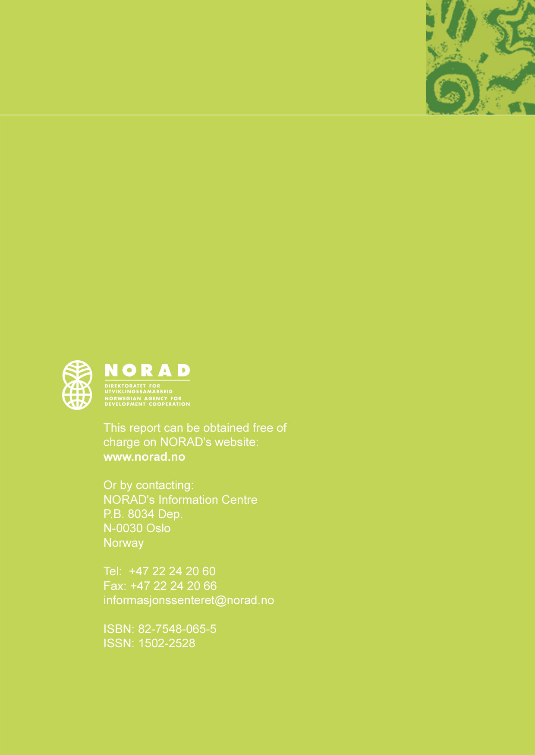

www.bistandstorget.no
For a brief (2 pages) and good discussion of reasons for and consequences of high interest rates, see CGAP Donor Brief No. 6 2002, "Making sense of microcredit interest rates", www.cgap.org/assets/images/Donorbrief6.pdf
Norway has been a member of the SED Committee for more than a decade. The guiding principles referred, the so-called "Pink Book" from 1995, is available at: www.sedonors.org
Many resources on these topics are gathered at the “Client Targeting Centre” and the "Impact Assessment Centre" at the Microfinance Gateway (www.microfinancegateway.org).
IFAD, DFID, NORAD, Sida, Asian Development Bank, African Development Bank, UNDP/UNCDF, and KfW.
See for instance www.microsave-africa.com
For a brief and recent overview of microfinance impact assessment studies, see www.cgap.org/html/p_focus_notes24.html and www.microfinancegateway.org/impact
For an illustration of the heterogeneity, see www.microfinancegateway.org and www.mixmarket.org
For instance, BRAC in Bangladesh has developed operationally separate but conceptually joint programs such as the IGVGD program focusing on food grain safety net, skills training, and financial services. In general, the Bangladeshi NGO community is an interesting example of big NGOs focusing on the voice of the poor.

