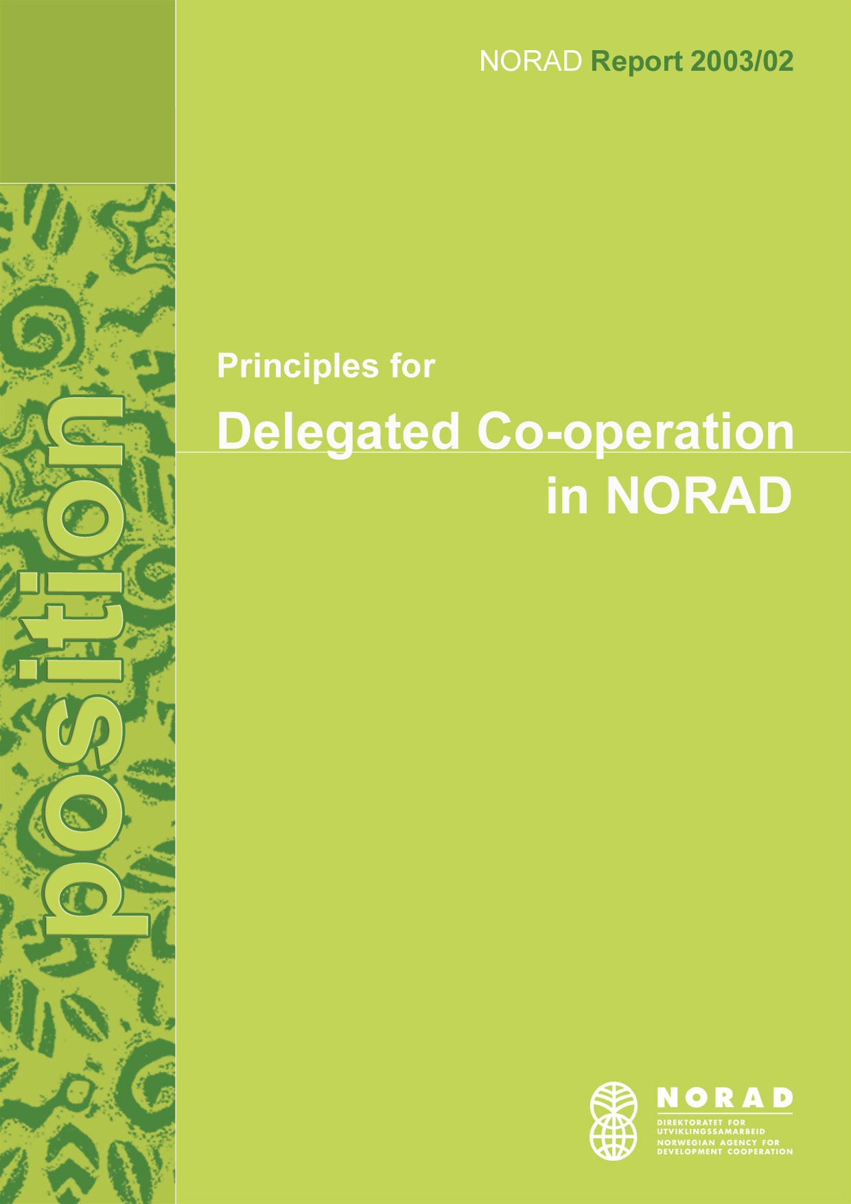

Content
Summary 3
Principles for Delegated Co-operation in NORAD 4
INTRODUCTION 4
POLITICAL FRAMEWORK 4
MAIN BENEFITS OF DELEGATED CO-OPERATION 5
DILEMMAS 6
NORAD'S POLICY 8
TASKS AHEAD 10

Annex: CRITERIA FOR SUCCESFUL IMPLEMENTATION OF DELEGATED CO-OPERATION BETWEEN DONORS
Summary

The following principles form the basis for NORAD's work with delegated co-operation:

- All activities should be in line with our partner country's priorities with regard to poverty reduction. This common policy-basis must be shared with our partner donor(s), as well as with the partner country

- Delegated co-operation arrangements should strengthen the partner country's ownership to its own development process. This normally presupposes a certain degree of leadership, motivation and willingness to manage the process of development, and the process of donor harmonisation

- A delegation arrangement should support the partner country's capacity building efforts and -needs

- Our co-operation arrangements should contribute to the partner government's accountability to its people. NORAD believes that donor co-ordination will result in increased openness on government spending and prioritisation

In order to achieve real benefits from delegation arrangements, the collaborating donors should make use of the partner country's administrative systems for accounting, audit, statistics etc. whenever possible. If these are not sufficiently well developed, capacity building should be prioritised.

The donors should harmonise their administrative requirements around one set of procedures. Only the lead donor should maintain a direct dialogue with the partner country's authorities. The interaction between the donors should be described in the agreement between them.

The partner country should be responsible for identifying possible needs for technical assistance, and such assistance should be subject to competition. The collaborating partners on their side must assure that the group of donors together has the necessary capacity and competence to carry out their obligations. The individual donor is responsible for fulfilling its designated role in the delegation agreement, with regards to own capacity and competence.

The legal and administrative requirements of the collaborating donors must be assessed prior to delegation.

Principles for Delegated Co-operation in NORAD
INTRODUCTION
This paper discusses questions related to delegated co-operation between bilateral donors in long term development relationships. It presents options and actions that follow from decisions on delegation, and it discusses guidelines for donor behaviour, being it as a delegating donor who takes a quiet role, or as an active donor who takes the lead.

We will as a rule describe delegated co-operation as a situation where one donor gives a power-of-attorney to another donor through a formal agreement between them, in order for the latter to administer funds and make decisions on behalf of both of them. The arguments we make are however valid for whether there is one delegating to one lead donor, or several delegating donors to one lead agency. There are many possible models for such donor collaboration.

The discussion will primarily address issues and dilemmas related to the delegation of authority between bilateral donors. Co-financing through multilateral arrangements has many of the same features, but the dilemmas and the implementation processes are different, and they are not discussed here.

This paper reflects NORAD's policy position today, and at the same time it invites discussion and reflection. It is a policy guide and should serve as an incentive for our embassies and staff. It will be the basis for more practical oriented means of implementation. We need to assess our legal and administrative status and –practises closely in order to be able both to delegate and be delegated to.

This document is prepared also as part of our obligation to follow up recommendations by our peers in international fora on development policy. NORAD hopes to be up-front and serve as a good example in the area of donor behaviour and alignment of practises at country level.
POLITICAL FRAMEWORK
Several arenas of development policy have defined and promoted the concepts of donor co-ordination, co-financing and alignment as means of simplifying donor-recipient relations and thereby increasing efficiency. Delegated co-operation has become an increasingly important theme for discussion , and agreements on delegated co-operation have been implemented in the field in some countries. Norway is among the few countries who has entered into formal delegation arrangements with other bilateral donors.

It is important to distinguish between donor harmonisation and donor delegation. It is quite possible to harmonise fully our procedures with others', without delegating authority. On the other hand, delegation presupposes a certain degree of harmonisation.

Over the last few years, the focus has moved away from looking at delegation of funding arrangements only, such as traditional co-funding or basket funding. The concept has been expanded to include delegation also of authority to make decisions, and today it concerns all stages of the cycle of activities in any development partnership.
The delegation of decision-making powers to others is a more complex question than the delegation of powers restricted to managing of funds. How can we give power-of-attorney to other donors, and at the same time be sure that our priorities are followed and our money spent wisely? How is it possible to maintain a dialogue with a partner if we do not meet on the political arenas we used to? How can we maintain our technical competence if we do not engage in the work in the field?

Partner countries were asked by the OECD which were the heaviest burdens to carry with regard to effective aid delivery. The survey aimed at identifying donor practises that placed the highest burdens on the partner country in terms of ownership, aid transaction costs and aid effectiveness. Three elements were clearly ranked as the most problematic:

- Donor driven priorities and systems
- Difficulties with donor procedures
- Uncoordinated donor practises

The same survey asked which changes would most likely contribute to improving the effectiveness of development assistance in their country. The most important elements were:

- Simplifying procedures and systems
- Harmonising procedures
- Alignment of procedures to the partner's systems
- Sharing of information
- Untying aid
- Respect for national priorities and strategies

These are the main arguments for NORAD in our conviction that delegated co-operation, one of many forms of donor co-operation and harmonisation, can be an important tool for improving performance. We believe it can make development co-operation more efficient, and thereby free both human and monetary resources for a greater and more effective effort globally.

MAIN BENEFITS OF DELEGATED CO-OPERATION
OECD/DAC has produced a Good Practice Paper on delegated co-operation which summarises the main benefits of delegation like this: "Delegated co-operation can reduce transaction costs and enhance aid effectiveness through greater use of the comparative advantage of individual donors".

In NORAD's view the range of possible benefits of delegation both for efficiency and effectiveness in development is large:

- increased efficiency through reduced administration, for the donor as well as the partner

- increased volume of co-operation without a related increase in human resources and administration

- funding of programmes or geographical areas where NORAD is not physically represented

- alignment of donor activities to national plans for poverty reduction, national budgets and other government instruments of planning in the partner countries

- a clearer voice as a group, towards the partner country, multilateral organisations or other large actors, rather than alone

- better use of the common technical resource base of the collaborating donors

- increased exchange of experience and mutual learning between the collaborating donors

- a sharing of responsibility between donors according to technical specialisation or competitive advantage

- more open communication between the partner country and the donors, and between the donors, on political priorities for development

- more funds channelled through "legitimate" channels and public budgets in the partner country

DILEMMAS
In order to enter into a delegation arrangement as a silent partner, we have to decide which aspects of the co-operation process we are willing to have a lesser degree of direct control over. Which elements can other donors do better than us? Where should we keep an active role for ourselves? The answers will vary from country to country, according to which form our activities have, and according to which donors we are considering collaborating with.

The logic that applies to results management is relevant to the considerations we have to do concerning donor delegation: At which stages of the results chain do we need to be "on the ball" in order to be fully responsible as a donor? Do we need to evaluate progress ourselves in order to be accountable? Could it be that an increase in co-ordination means that some policy area will be ignored because all donors focus on the same issues? How can we fulfil our politically determined goals?

In other settings, we must decide whether we are willing to carry the responsibility of acting on behalf of other donors. A theoretical approach to this is that in order to gain the full benefits of donor delegation, we should be willing to be lead agency for others in any situation where we have the greatest comparative advantage. It seems maybe a more realistic approach to imagine this as a burden-sharing agreement, where we find a certain equilibrium between being an active, leading donor in some areas, and one that delegates in others. The extra burdens related to being an active donor in one programme or country should be more than outweighed by being a silent partner in others.

The DAC Best Practise Paper states that "delegated co-operation arrangements should only be pursued when the resulting benefits outweigh the costs of setting it up…" The goal of reduced transaction costs might very well be overshadowed by an initial period of increased costs, due to the harmonisation process itself. However, once the alignment processes between the donors and between the donors and the partner have been accomplished, there should be a potential for gains. If this potential is not clear, the situation is probably not a good case for delegation.

We need to be aware of the fact that the Norwegian contribution to the development process will be far less visible when it is spent through another donor. We might be accused of not being able "prove" our achievements. However, these are questions that already are on our agenda with regard to other issues, such as the implications of budget support. We need to address the issues of monitoring and evaluation in any case, and to move the focus from measuring achievement by "activities" and "output", to "impact".

If we delegate authority to other donors for instance in the field of policy dialogue, there is a risk that we lose information that we feel we need in order to maintain our own competence. If we don't have regular direct contact with the partner country's administration, and we don't work "hands-on", it is possible that we lose out on updated country and development information. While this can seem a potential problem, it is a characteristic of donor co-ordination that has a clear potential benefit also: All donors do not need to have the same updated knowledge base in all fields. The challenge lies primarily in the relationship between the collaborating donors with regards to sharing of information. Our own expertise and knowledge might be increased dramatically in one area and reduced in another. But our access to the common knowledge pool should be unlimited.

There are also dilemmas with regards to technical assistance. An implication of our policy on partner country ownership, is that the partner should be responsible for defining possible need for technical assistance. This means that the donors no longer control the delivery of such aid, which in line with international recommendations on untying of aid should be ordered from the most competitive source, being it the lead donor, a silent partner or any other bidder.

Strict open competition on technical assistance could result in donors maintaining only very narrow areas of specialisation, which could result in a lesser capacity for a holistic and realistic approach to the development process. There is a need for all donors to maintain a critical mass of expertise, and a sufficiently broad one. These are issues that warrant attention. However, the dilemmas related to competition are in our view general in character. Greater competition will probably challenge us in the near future anyway, as the issue of untying aid becomes more clearly defined and the practise of competition becomes more common.

Efficient donor co-operation requires that all donors look closer at their own technical specialisation and see this in relation to the common resource pool of the donors as a whole. As we might become a source of expertise and a dialogue partner in some areas, we might be a quiet funder in others, where somebody else has a greater potential. With this process comes a greater choice. In a delegation arrangement, we can define more easily ourselves which level of activity and responsibility we wish to have in each sector, programme, or region. We do not have to be on top of all issues in all fields, but can concentrate on fulfilling the role that we wish to take, and make sure we command over sufficient expertise in this area.

There is another dilemma in the fact that co-operation between institutions, for instance between offices of ombudsmen or auditing-generals, could be defined as technical assistance and therefore become more difficult to facilitate directly between donor and partner country than it is today. These relations between institutions are not necessarily interchangeable between donors, and rely on long term relationships. It could very well be that the partner country specifically asks for an agreement with a Norwegian institution, and where an agreement with an other donor's alternative not really is an option.

However, we believe there is a distinction between a situation where two institutions build a long term mutual learning relationship, and where the donor country institution delivers a technical consultancy. We will have to learn to distinguish better between the two, and accept that competition could give the best results in the latter case, but probably not for the first. For these relationships, NORAD should consider whether the Norwegian institution is the best supplier of the relationship that the recipient country institution seeks.

Some will argue that there is a value in itself in the interchange between technical assistance and institutional dialogue and that they reinforce one another. From experience we know that both definitions and priorities related to technical assistance vary greatly between donors, also between ones we normally co-operate closely with. The issues related to technical assistance should therefore be carefully considered when we discuss potential delegation partnerships with other donors.

NORAD'S POLICY
We define donor delegation as when one "lead" donor acts with authority on behalf of one or more other delegating donor(s). The level and the form of delegation can vary from concerning only elements in a project cycle, for instance a specific appraisal, to a complete sector or country programme. Delegation can concern the authority only to disburse funds, or responsibility for the process of dialogue with the partner. It may cover both, and a range of organisational models are possible.

In projects, delegation can be an option for analytical work, monitoring, reporting, audit, or any other element in the activity chain. Financial assistance can be channelled through one donor to the beneficiary, and the responsibility for the following-up can be delegated partly or entirely.

In macro economic budget support settings, donors can delegate responsibility for the policy dialogue for instance on sectors, but also for analytical work, monitoring and auditing, for instance. One could also imagine rotating responsibility for dialogue processes between the collaborating donors and the government. The benefits of channelling funds through other donors in a budget support setting seem more limited, unless in situations where the delegating donor is not represented physically.

In sector programme settings, delegation can be an option with regards to managing funds for other donors, and with regards to elements in the cycle of activities. Donors may support components, or the whole programme, and delegation may occur in any form relevant to the particular combination of donors, their funding and the set of activities between them.

The OECD/DAC Best Practise Paper on delegation describes different delegation arrangements that have been implemented, and summarises what seem to be important conditions for success in the implementation. A summary of these conditions is attached in the annex.

However, there are some more fundamental assumptions that need to be defined. Below are listed the principles that NORAD will aim to adhere to in our efforts to improve donor behaviour through delegation of authority:

- All our activities should be in line with our partner country's priorities with regard to poverty reduction. Irrespective of how we organise our work, we should always look for this in our approach to a partner country. However, in a delegation arrangement, we have to make sure that we share this common policy-basis with out partner donor, as well as with our partner country.

- A delegation arrangement should support the partner country's capacity building efforts. This implies that not only the choice of sector or programme, but also the choice of organisation of our work, should be done in line with our partner country's present capacity, and its capacity building needs.

- Concerning administrative tasks such as statistics, auditing or accounting, we should use the partner country's administration whenever it is possible. We should focus on capacity building when it is not possible. Until the partner country's administrative procedures are sufficiently well developed and can be the basis for the donors to align to, the donors should harmonise their administrative routines around one set of procedures, normally the lead donor's.

- Delegated co-operation arrangements should also strengthen the partner country's ownership to its own development process. This normally presupposes a certain degree of leadership, control, motivation and willingness to manage the process. There will be many countries among our partners where these conditions cannot immediately be met. In situations where the partner country is not ready to take a leading role, there is a greater danger than elsewhere, of donor harmonisation taking the form of "ganging up".

- Partner country ownership implies that it is the partner country that defines the need for technical assistance, and this should be subject to principles of untying of aid and competition for the most suitable offer.

- Co-operation arrangements should also contribute to the partner government's accountability to its people. This implies that increased openness, transparency and good governance must be the basis for the organisation of the partnership, both between the donors, and between them and the government. NORAD believes that donor co-ordination will result in increased openness on government spending and prioritisation.

- Whether or not NORAD is the lead donor or a delegating donor, we are responsible for being sufficiently well equipped with regard to personnel, technical competence or other, to fulfil our designated role. Our embassies are responsible for ordering advice from headquarters in order to assure that we have the capacity and competence needed to be able to carry out our part of the delegation agreement.

- The agreement between the donors should describe the requirements necessary to fulfil each donors' minimum legal standards and administative routines. This concerns reporting requirements, disbursement triggers etc. In the future, one might be able to develop a model of common minimum standards for donors to build their co-operation agreement on.

- It should always be the lead donor who maintains the dialogue with the partner country's authorities. Normally, the delegation agreement between the donors will define that the delegating donor may attend reviews and annual meetings, for instance. Possible questions and grievances related to implementation should be addressed to the lead donor bilaterally, at the crossroads intended for this purpose. Delegating donors should not engage in a technical dialogue with the partner country unless this is clearly in understanding with the lead donor.

- Although the fundamental motivation behind delegation may be the reduction of transaction costs, this in itself is not a goal. Reduced transaction costs is only a means for increased efficiency. We believe that in many countries and situations, the efforts made to implement donor delegation will increase transaction costs initially – but that this will be outweighed by a long-term efficiency gain. However, a thorough appraisal must be made prior to a decision on delegation, so that the probability of a long-term benefit is clearly positive.

TASKS AHEAD
We will ask our staff at headquarters and at the embassies to look actively for possibilities of delegation – both from NORAD to other donors and the other way round. Can we stop doing some of our activities, in order to let somebody who is more qualified/has free capacity/is represented locally can do it for us? Could we imagine going into a country where we would like to work, but where the initial administration burdens are too large? Can we offer our services to another donor in a situation where our competence is evident and the development process could gain from a larger volume of support?

Delegation of authority means that we must trust other donors' competence and judgements, but we may also wish to rely on their routines for implementation. In order to prepare the ground, we will perform informal surveys of a few likeminded donors that we believe Norway could delegate responsibility to. Our survey will build on a similar process that Sida has carried out.

We will also assess our own organisation in order to establish whether NORAD has the necessary flexibility and mandate to participate fully in harmonisation and co-ordination activities such as delegated co-operation. We will review our existing guidelines for project and programme management with a view to donor delegation and revise our manuals accordingly.

We also need to assess our own practise with regard to standards for agreements. NORAD's legal department will pursue the issue of developing a minimum legal standard for donors, so that agreements may be harmonised internationally. This will benefit co-operation in general, but delegating arrangements specifically.

NORAD will be active in the work of the OECD/DAC in order to promote and further develop the concepts of donor harmonisation, co-ordination and alignment. We will also work to disseminate and implement the recommendations that are made in the OECD/DAC on donor behaviour.

Today's statistical tools do not sufficiently well reflect co-funding and financing through other donors. This must be addressed, also in international arenas, so that our statistical support and information is relevant. There are additional methodological challenges that concern our documentation of results in development, and the allocation of resources to respective results in the field.

We will at regular intervals evaluate our own progress in the field of harmonisation, and the practise of delegation as one element of this. We wish to be an active change agent for efficient donor behaviour, and will prioritise both the development of guidelines and the implementation of change within our own organisation in order to achieve this.
ANNEX:

CRITERIA FOR SUCCESFUL IMPLEMENTATION OF DELEGATED CO-OPERATION BETWEEN DONORS

The DAC Good Practice Paper on Donor Delegation refers to and evaluates existing delegation arrangements between donors. It sets out principles that seem to have been important conditions for successful relations between the donors that delegated, and between them and the partner country:

- The donors must agree on the objectives for the co-operating arrangement. This is a different issue from agreeing on the purpose of the development project/programme itself

- Full use should be made of the individual donor's comparative advantage, in a sector, country or on specific tasks, when they decide the sharing of work and responsibility between them

- The extent of preparation should reflect the scope and scale of the delegation arrangement; the time and resources put into the preparation phase must be in proportion to the scope of the activity or budget

- The partner country should be consulted on the delegation arrangement, and if possible give advice on the division of responsibility between the donors

- Delegation arrangements must be as simple as the situation allows for. If the delegation concerns only one specific activity, the scope and detail in the agreement can be less than if it concerns a whole chain of activities

- The donors must evaluate each others organisations in order to establish their mutual suitability as delegation partners, especially with regard to legal and administrative requirements. The extent of this evaluation must be adapted to the purpose of the collaboration; its time frame, scope and character. Such evaluations should be shared between donors.

- The donors should align their administrative procedures to the partner country's, or if not possible, they must agree on one set of procedures. The most likely choice would be the procedures of the lead agency. They should in any circumstance consider capacity building in order to increase the partner country's capacity and competence

- The donors must have a clear understanding of the respective roles and responsibilities of the donors, and share this with the partner country. These responsibilities should be described in a written agreement. The details of any delegation agreement should be publicly available.

- Where the delegation arrangement includes channelling of funds, there must be a written agreement between the active and the delegating agencies on disbursement, accounting and auditing arrangements, including details like the treatment of interest accrued, disbursement triggers, nature, scope and frequency of financial reporting, transfer modalities etc.

- The legal status of any written agreement should be clear

- There should be a common understanding between the donors on the number of agreements to be made between the active donor and the partner country under any given delegation agreement between them

- The active and the delegating donors should agree on indicators for performance measurement, at activity, output, outcome and impact levels of the results chain.

- The donors must adhere to the agreed roles and procedures

As well as these conditions, the paper describes role models for the lead and the delegating donor(s) respectively:

The (potential) lead donor should:

- enable (potential) delegating donors to review their project/programme implementation cycle, procedures and legislation relevant for the delegation arrangement
- make sure all parties' expectations to the delegation arrangement are clearly understood and assess whether these expectations are likely to be met
- adapt its procedures to the partner country's, and/or facilitate alignment between the other donors to one common set of procedures
- be responsible for a dialogue with the partner country with regards to the delegation arrangement prior to its implementation

A (potential) delegating donor should:

- assess the lead donor's procedures in order to be satisfied that they fulfil own requirements
- state own expectations and understanding of other's expectations clearly
- align procedures to one common standard
- review their own (existing) agreement with the partner country to make sure the delegating arrangement does not violate any part of or intent in this

NORAD Reports

Year Nr Title Type
00 1 NORAD's Good Governance and
Anti-Corruption Action Plan 2000-2001 Position

01 1 Coordination of Budget support programmes Discussion
01 2 Poverty Reduction Strategy Processes in Partner Countries Position
01 3 Aids handlingsplan Standpunkt
01 4 Aids Action Plan Position

02 1 Study on Private sector Development: Summaries Discussion
02 2 Study on Private sector in Bangladesh Discussion
02 3 Study on Private sector in Malawi Discussion
02 4 Study on Private sector in Mosambique Discussion
02 5 Study on Private sector in Sri Lanka Discussion
02 6 Study on Private sector in Tanzania Discussion
02 7 Study on Private sector in Uganda Discussion
02 8 Study on Private sector in Zambia Discussion
02 9 Ownership and partnership:
Does the new rhetoric solve the incentive problems in aid? Discussion
02 10 Study of Future Norwegian Support to Civil Society in Mozambique Discussion
02 11 Report of a study on the civil society in Uganda Discussion
02 12 Private Sector Development in Albania Discussion
02 13 Private Sector Development in Bosnia and Herzegovina Discussion
02 14 Rewiew of Christian Relief Network in development co-operation. Discussion
02 15 Budsjettstøtte Standpunkt
02 16 Direct budget support/ Position
02 17 Fattigdom og urbanisering Standpunkt
02 18 Urbanisation Position
02 19 Information and Communication Technology (ICT) Position

03 1 Helse i utviklingssamarbeidet Standpunkt
03 2 Principles for Delegated Co-operation in NORAD Position

NORAD's list of publications comprises two categories: Position is NORAD's official opinion, while Discussion is a forum for debate which not necessarily reflects NORAD's policy.
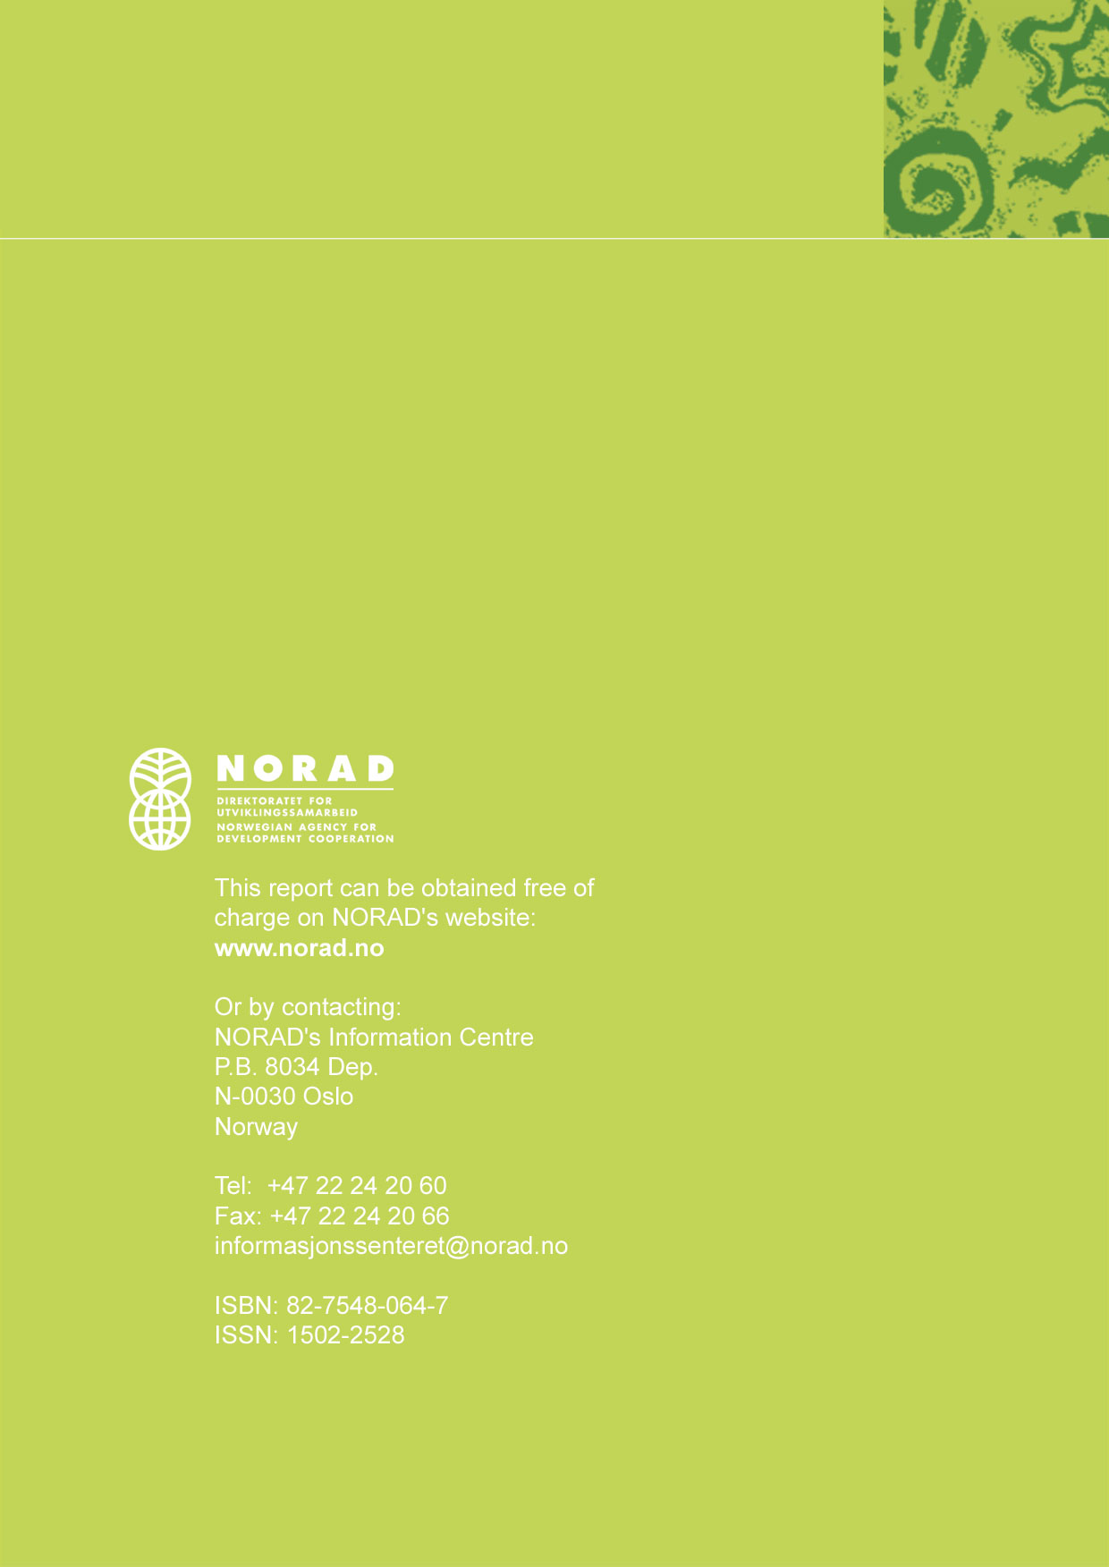

In Norway, NORAD is responsible for long term development assistance, whereas the Ministry of Foreign Affairs is responsible for short term (humanitarian) aid and financing through the multilateral organisations.
The OECD/DAC Task Force on Donor Practises and the World Bank/OECD High Level Forum on Harmonisation have provided the most extensive new policy documents in this area.
The Swedish delegation arrangement with NORAD in Malawi is an often quoted example of a complete country portfolio being administered by one donor on behalf of another.
Needs Assessment Survey, carried out by the University of Birmingham for the OECD/DAC TFDP
DCD/DAC/TFDP(2002)12/REV1
A more detailed list of criteria for success is attached.
DCD/DAC/TFDP(2002)12/REV1

