Conservation International

Building Vertically Integrated National to Local REDD+ Readiness in Peru

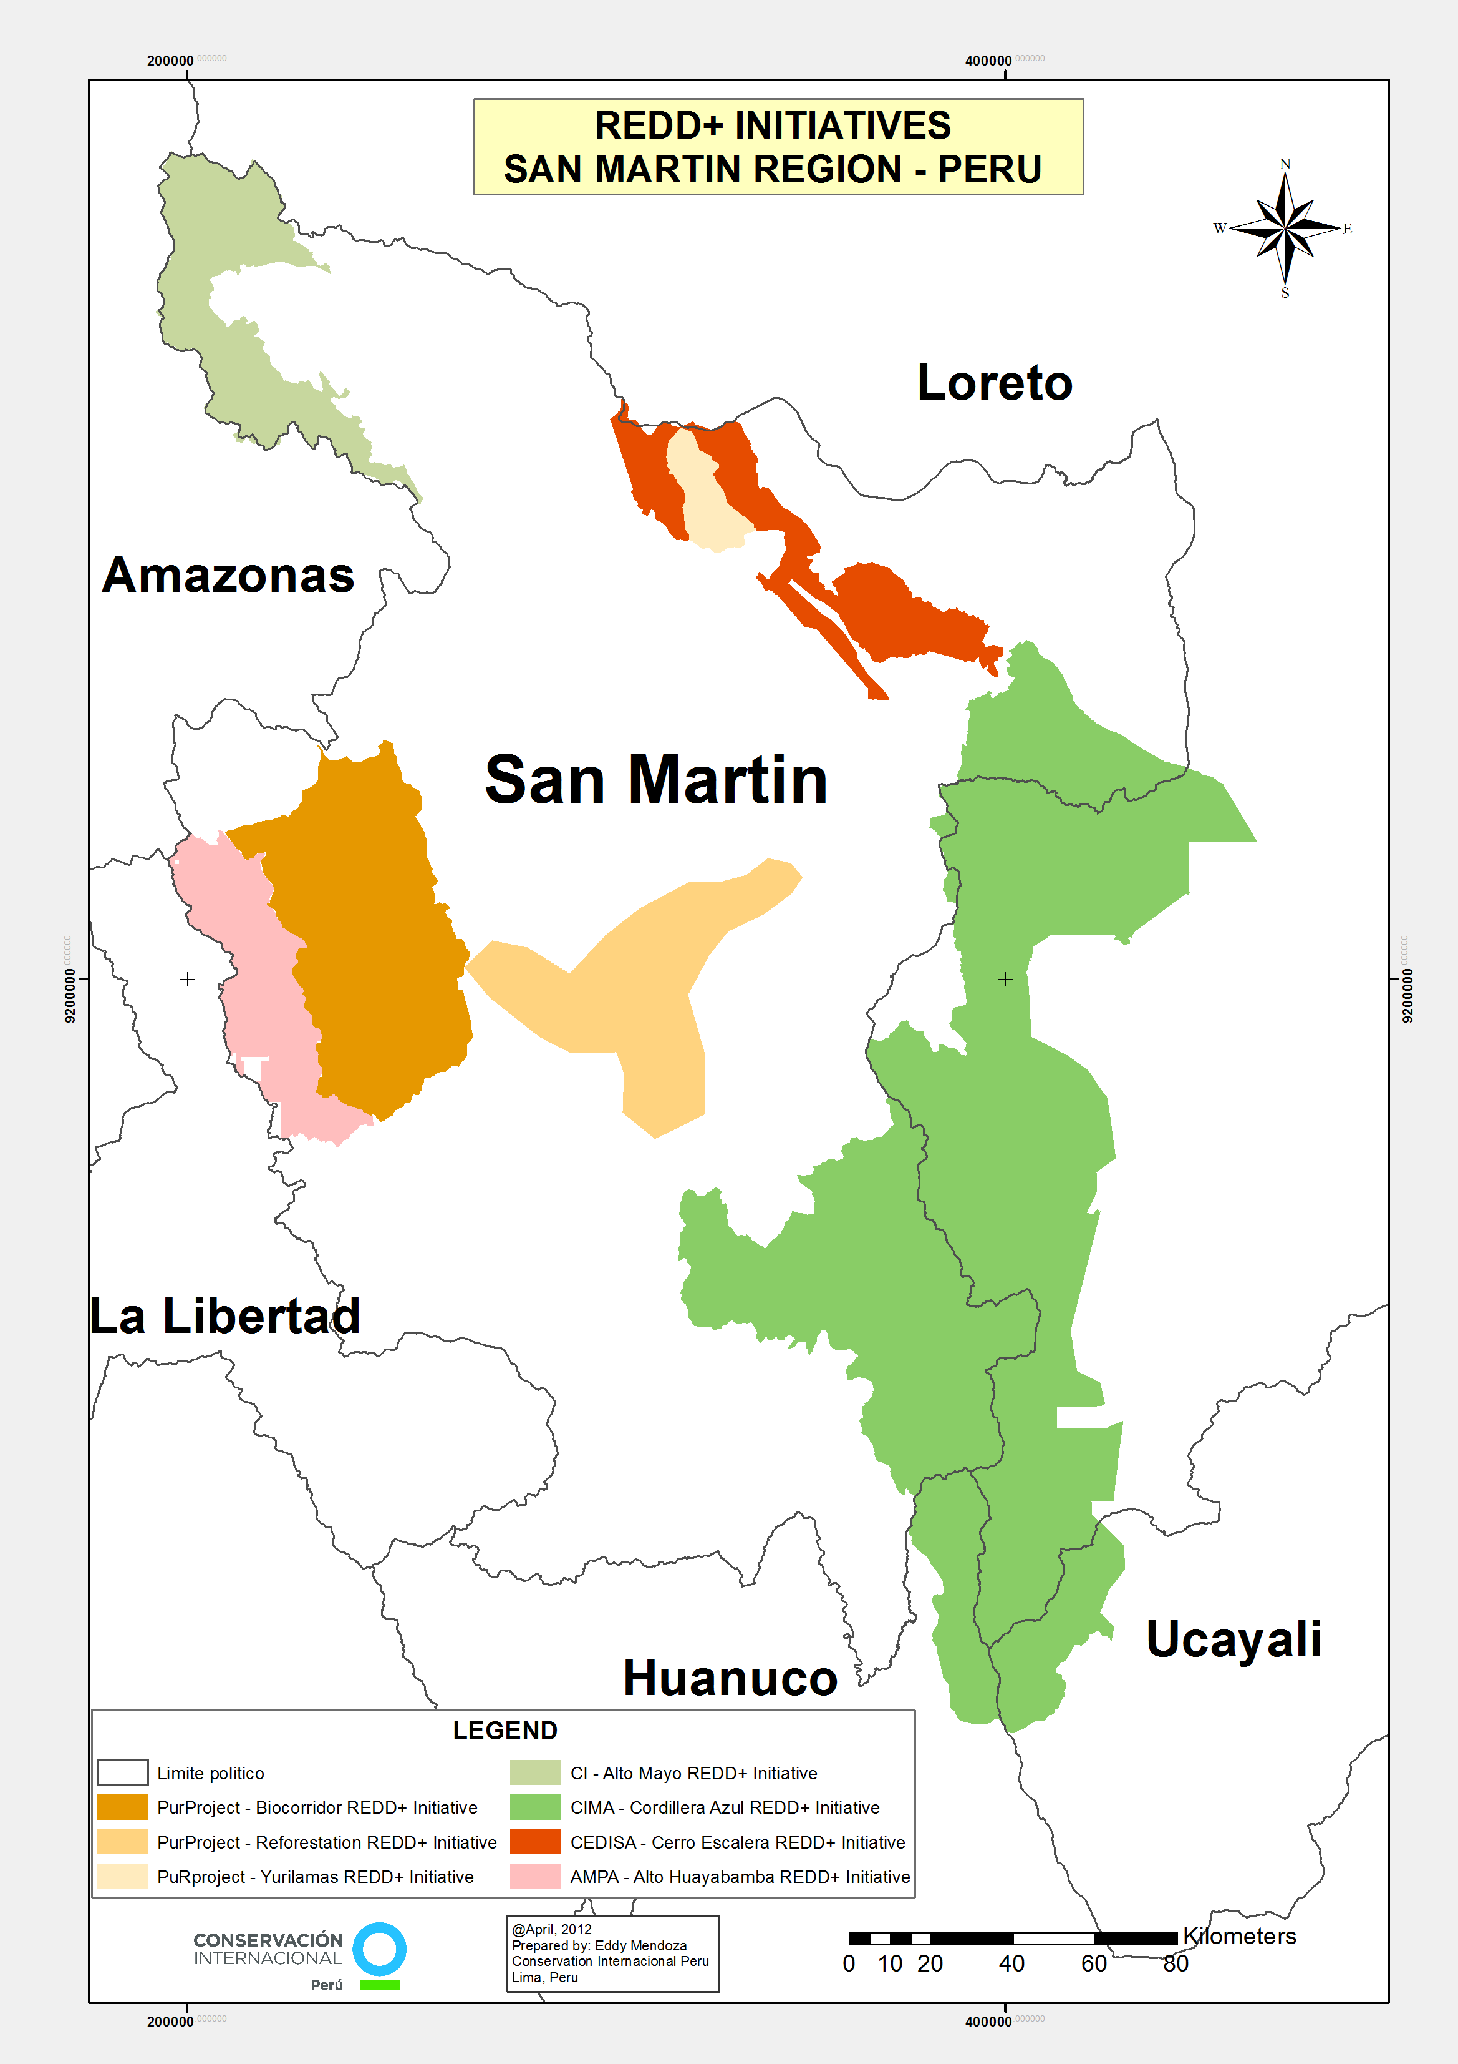
1. Project summary

Conservation International (CI) in Peru is working with San Martin’s regional government, local organizations and key partners to collaboratively develop a Jurisdictional and Nested Framework for REDD+ with the long-term goal that this framework will eventually be used in the rest of the country and serve as a model to set national standards. To this end, CI is contributing to a regional REDD+ readiness plan that could be replicated for the design of a national strategy. These plans include steps to build capacity for obtaining prior informed consent from indigenous leaders. Efforts have been made to engage these leaders in creating strategies that benefit the poor and ensure equitable distribution of REDD+ financial benefits.

Capacity building efforts under this project also included the development of regional reference scenario for emissions from deforestation aimed at results-based financing. As a result of this effort and the political will of the Government of San Martin, this region is at the forefront of REDD development in Peru. This has been officially recognized by the Peruvian Government in the national REDD Readiness Preparation Proposal (R-PP).

Norad funding has allowed CI to work on REDD+ analysis, concept and methodology development in cooperation with the Government of San Martin and local partners. This is resulting in the construction of a jurisdictional and regulatory framework for REDD in San Martin. The project adds an important piece to CI’s work on the landscape level in the Alto Mayo region and San Martin as a whole. This work seeks to reconcile classical development activities like infrastructure and expansion of agriculture with the conservation of forests and biodiversity. REDD+ is an important mechanism in that effort and is used alongside capacity building, harmonization of development plans, and participation of local stakeholder through, e.g. conservation agreements and the adoption of more sustainable practices, targeting REDD+ relevant commodity supply chains.

2. Project information

- Support period: 2010-2013; budget frame: 9,512,399 NOK; expenditures to date: 96%
- The goal of the project: The overall goal is to contribute to building a national level REDD+ readiness, based on sub-national and site-based activities, focusing on governance, human and institutional capacity, structuring effective financial instruments, ensuring extensive stakeholder consultation, integration with community economic development plans, sound benefits sharing programs, robust carbon quantification and monitoring and sound institutional links between national and subnational levels.
- Target group: Regional Government of San Martin, civil society stakeholders, Peruvian Ministry of Environment, indigenous and local communities of San Martin.
- Local partners and their responsibilities in the project: Regional Government of San Martin responsible for leading the REDD+ development process and REDD roundtable in the region; Universidad Nacional Agraria La Molina (UNALM), responsible for deforestation analysis and capacity building; Carbon Decisions International (CDI): responsible for technical support and reference scenario methodology and capacity building.
- Other donors to the project: The Gordon and Betty Moore Foundation provided financial support in the early stages of this project. The Walt Disney Company and USAID have provided funding for the development of the Alto Mayo REDD+ project and the Sustainable Landscapes Partnership for Peru initiative.

3. Justification of project

Ranking fourth among tropical countries with high forest cover, Peru is well positioned to promote REDD+ as a national strategy to reduce deforestation levels and mitigate climate change. Nonetheless, technical capacity and legal instruments need to be further developed for the successful implementation of a REDD+ strategy in Peru. While there is interest from indigenous groups and regional governments in promoting REDD+, there is still a need to strengthen local capacity for these groups to be effectively engaged in REDD+ development.

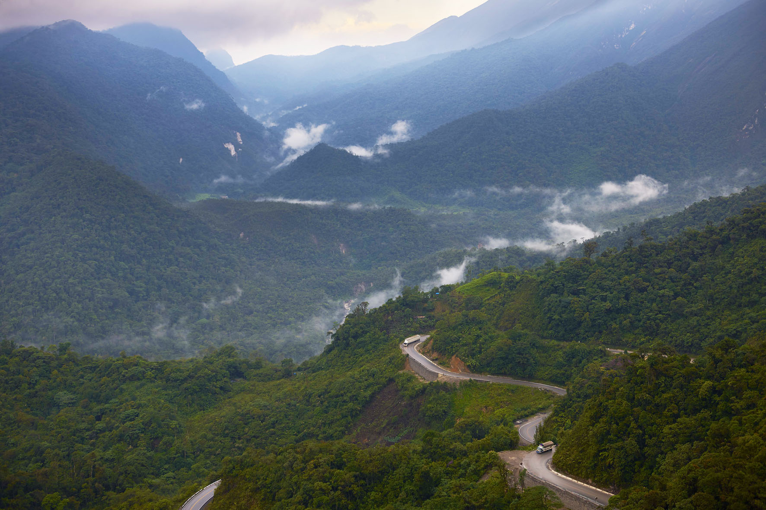
The government of Peru has indicated its interest in capturing the potential economic, social and environmental benefits associated with REDD+ through its submission of the R-PP to the Forest Carbon Partnership Facility (FCPF) hosted by the World Bank. The proposal was approved in March 2011. In this context, the Peruvian government has decided to take a nested approach to REDD+ and adopt a bottom-up, multi-scale approach to implementation, starting at the local or site level, and continuing to the regional or subnational level and then moving on to the national level. Consequently, REDD+ activities are being developed at different scales of planning and implementation, and early initiatives are at different stages of development.

The Peruvian Ministry of Environment (MINAM) has begun the process of building political support for the development and integration of diverse instruments, including REDD+ that will help enforce forest governance. An innovative instrument of the Ministry of Environment is the National Forest Conservation Program to Mitigate Climate Change, which will provide incentives to indigenous communities to conserve their forests.

4. Results

The San Martin Regional REDD+ Roundtable
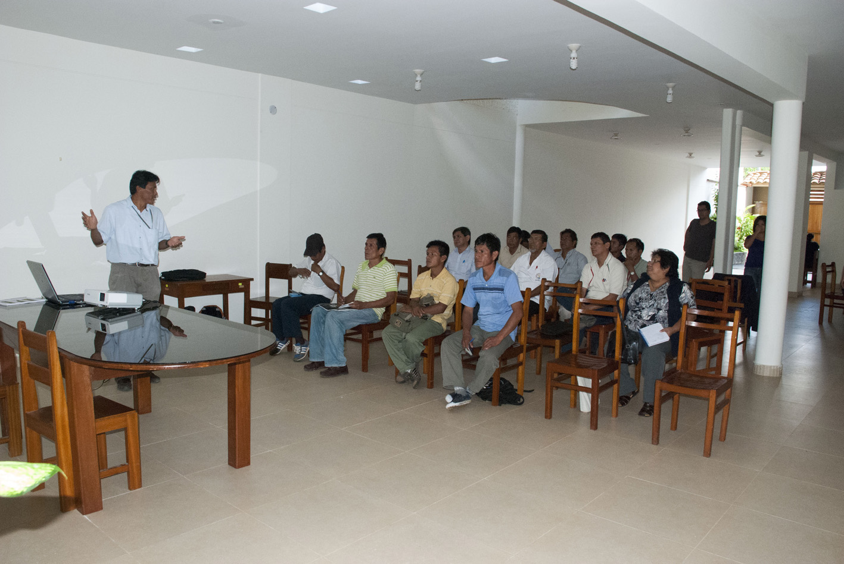
The San Martin Regional REDD+ Roundtable is an open forum for discussing REDD+ at the regional level. It is chaired by the regional government and includes representatives from civil society organizations and REDD+ experts from the national government (MINAM). Enhancing the integrity of the region’s REDD+ framework, the Roundtable created an advisory committee and a technical working group to analyze the drivers of deforestation, develop reference scenarios and assess carbon stocks.
Roundtable participants emphasize the social aspects of REDD+ and encourage processes that effectively engage stakeholders.

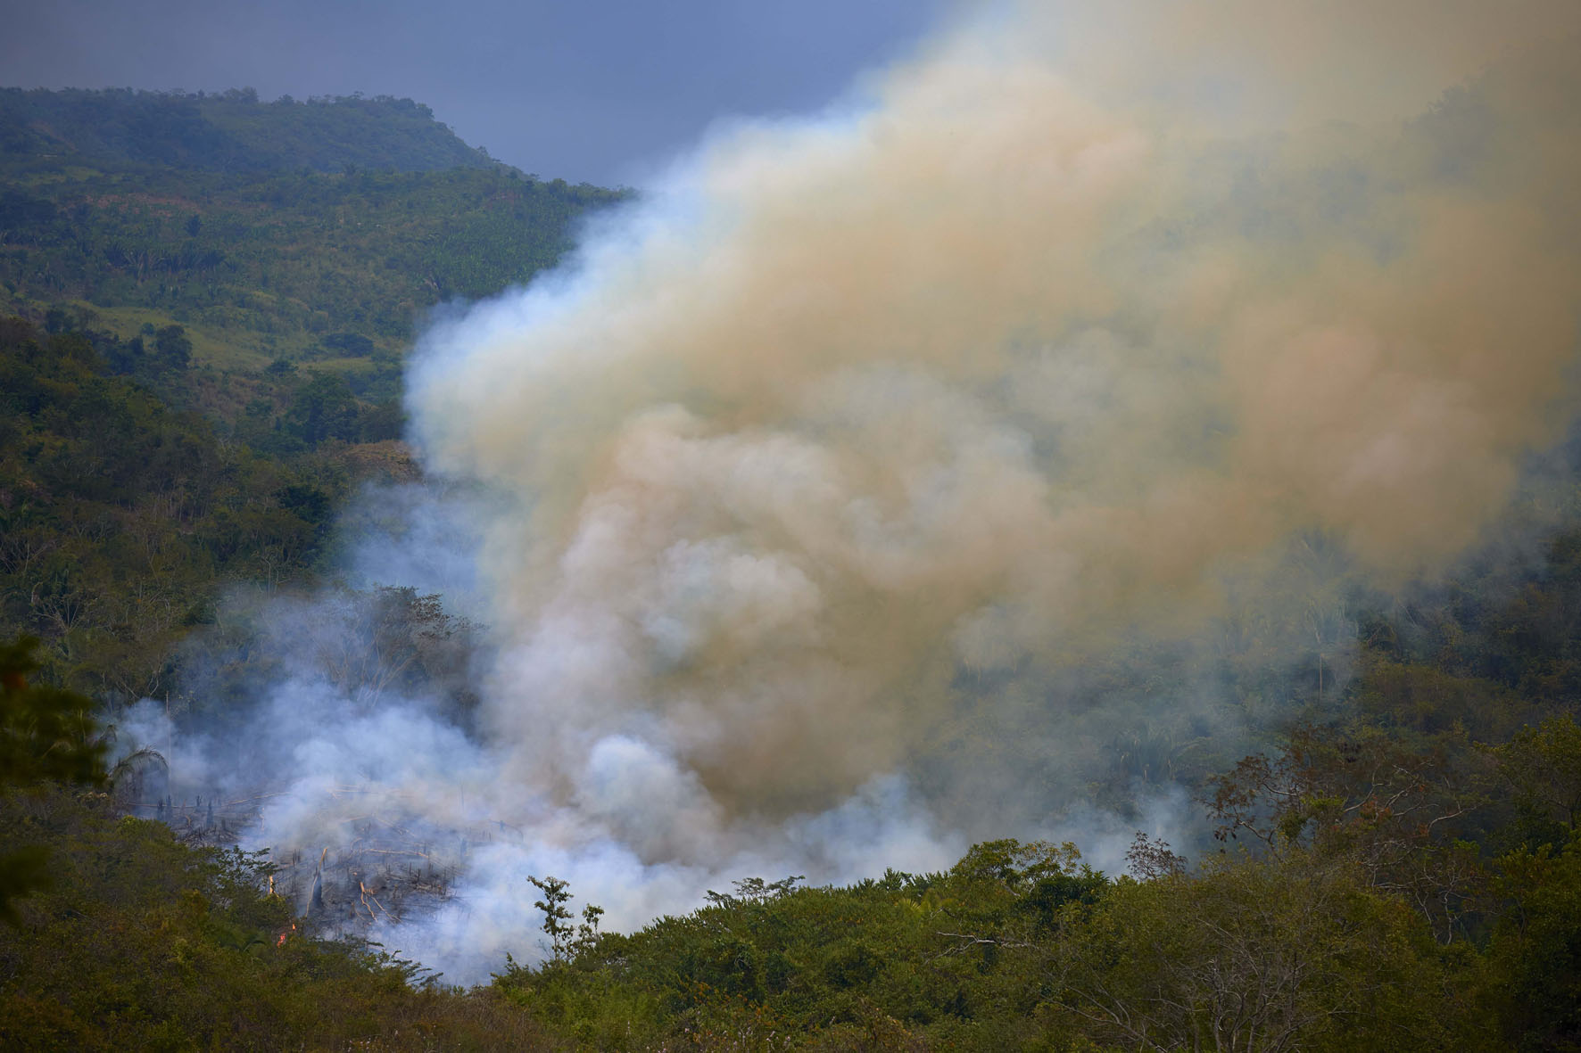
Historical Deforestation Levels
CI’s Science and Knowledge Division provided change detection training to four analysts at UNALM. 90 Landsat images were used to generate historical deforestation data for the periods 2000-2005 and 2005-2010. To test the accuracy of this analysis, CI, in collaboration with local partners, analyzed high-resolution aerial photography and conducted field surveys to acquire the necessary data for validation.

Deforestation Scenarios
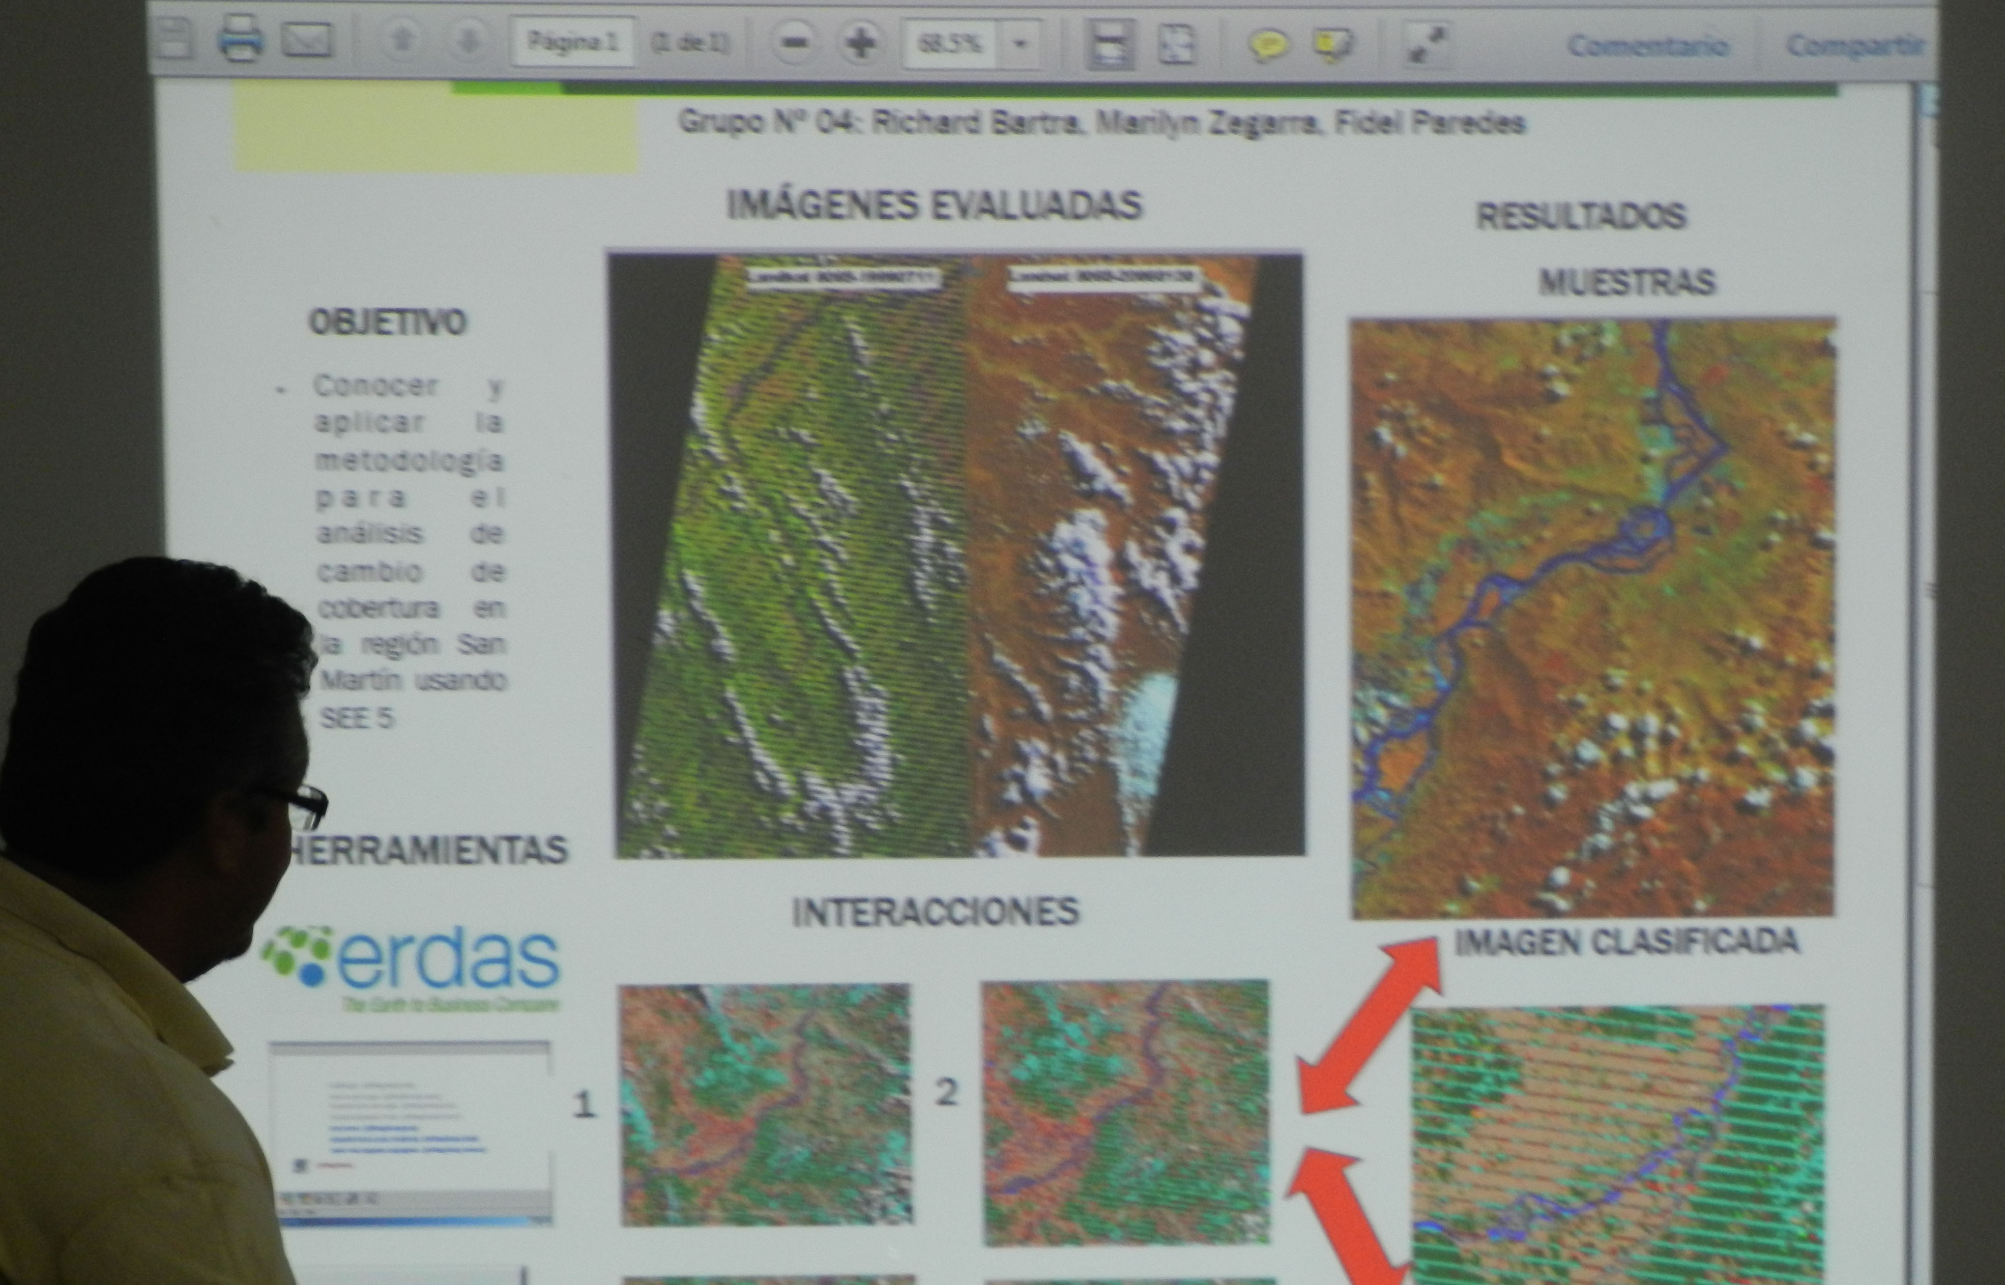
The REDD+ Roundtable’s technical working group collaborated with Carbon Decision International (CDI), a CI partner, to produce a report on the agents and drivers of deforestation in the San Martin region. The results of this analysis were used to develop deforestation projections. Because these projections are spatially explicit, they can also be used to determine the baseline of local REDD+ initiatives.

The underlying database of geographic driver variables was created, reviewed for accuracy and improved by the technical working group. The projections were calibrated using UNALM’s data on historical levels and locations of deforestation. After review by the advisory committee, the projections were presented to the REDD+ Roundtable where local experts provided feedback and suggestions. The aim of this iterative process was to produce a credible final deforestation projection.

Carbon Stock Inventory and projection of GHG emissions from deforestation in San Martin
In collaboration with the technical working group of the REDD+ Roundtable, CDI has produced a carbon stock inventory report for San Martin. This report describes the compilation and analysis of carbon measurement data collected from several institutions. The data contain carbon measurements from 466 field plots as well as geographic information that was used for stratification in carbon density classes. This information was used in combination with the deforestation projections to develop a 30-year projection of greenhouse gas emissions caused by deforestation in San Martin.

Capacity Building
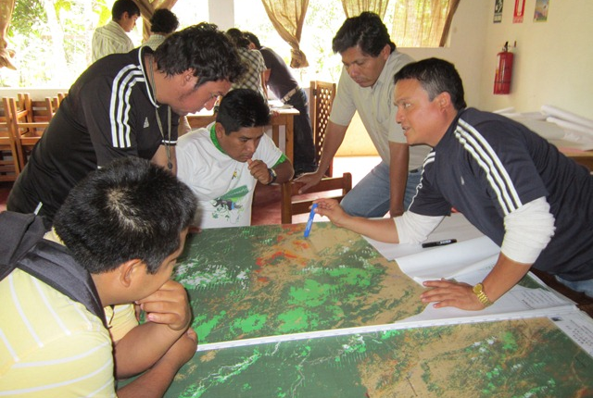
Together with the REDD+ Roundtable, CI is supporting capacity-building activities to facilitate understanding of the methodologies used in developing deforestation analysis and carbon stock inventories. The preliminary results of deforestation analysis will be presented to various stakeholder groups, including several offices of the San Martin regional government, members of the San Martin REDD+ Roundtable, representatives of indigenous federations and the Peruvian National Park Service.

Capacity-building efforts have included on-the-job training, working sessions conducted with the REDD+ Roundtable and three workshops. CI is also funding a geospatial technician to work exclusively with the government of San Martin. CI and CDI have conducted two workshops to address technical and regulatory issues of the nested approach to REDD+, including how to build a reliable, effective and multi-purpose MRV system. CI-Peru’s built a team of skilled local trainers to deliver workshops to communities and local stakeholder groups on issues related to climate change and environmental services.

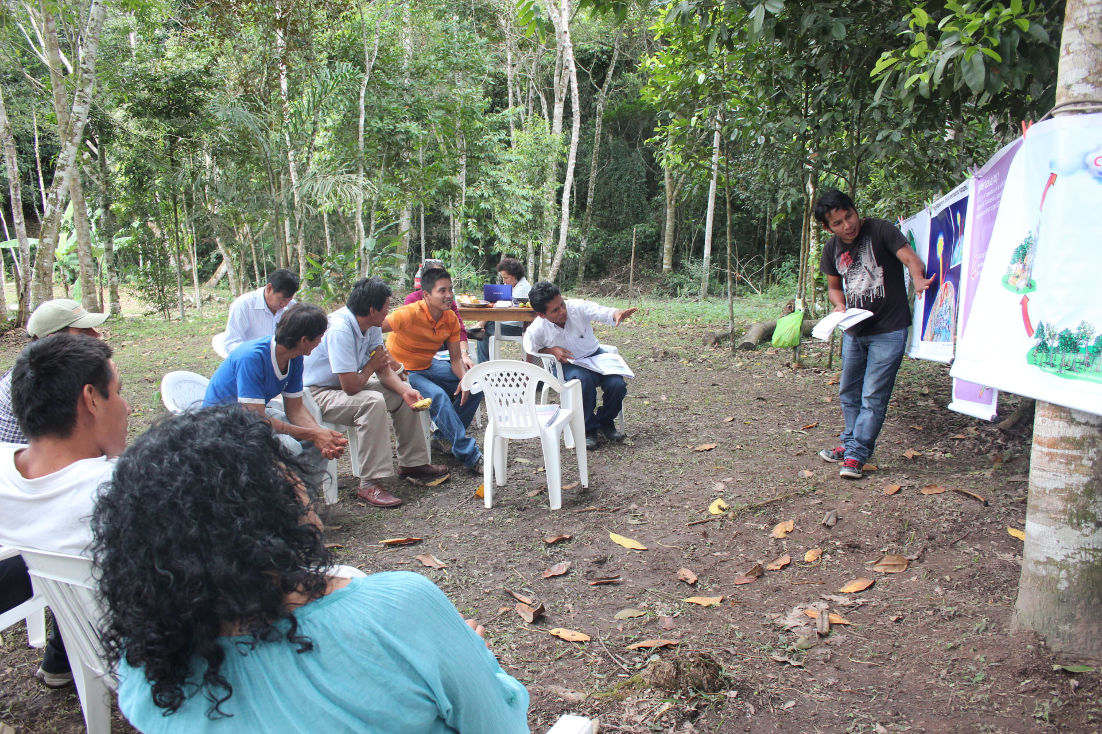
Through this process, CI assisted the regional government in establishing a local stakeholder consultation program that addresses indigenous peoples’ and local communities’ needs within a nested framework of REDD+ incentives. CI is committed to effectively involving indigenous people in the regional development process by supporting the Regional Environmental Authority (ARA) and the Indigenous Peoples Regional Development Office (ORDEPISAM). CI Peru is working with partners to empower indigenous groups in ecosystem services schemes.

These efforts have been conducted in collaboration with the San Martin regional government and the National Forest Conservation Program to Mitigate Climate Change.

One important aspect of the capacity building plan lays out a prior informed consent process with indigenous leaders, how to involve them at all levels of the process and strategies for distributing REDD+ benefits. A first step toward effective engagement is the dissemination of information.
To this end, CI-Peru conducted a long-term training-of-trainers course on climate change and the role of forests for representatives of San Martin’s indigenous regional federations.

Development of a regional REDD+ readiness plan
The project accomplishments during the first two years of NORAD funding have positioned San Martin as a pioneer region in the development of nested and jurisdictional REDD+ in Peru and probably in the world. Outcomes obtained through the project, both in the technical and social aspects of REDD+, are providing valuable inputs and lessons learned to national level discussions. In light of these advances, the Peruvian Ministry of Environment appointed a REDD+ technical liaison at the San Martin Regional Environmental Agency.

This liaison works closely together with the San Martin Government and is the Technical Secretary of the REDD+ roundtable. This appointment has been decisive for facilitating and strengthening coordination between the National and Regional Government levels and created a mechanism for the development of institutional arrangements for REDD+, with support of the civil society and local communities, and under the framework of the regional REDD+ roundtable. This is one of the best examples of the political impact of the project has had thanks to the financial support of NORAD, one that is being replicated in other regions of Peru, such as Madre de Dios.

Under the framework of the REDD+ roundtable important steps are being taken on several fronts to create an overarching strategy that will set up the necessary elements for jurisdictional and nested REDD+ to take place. Undeniably, the participatory and collaborative work, between government and civil society, being conducted under the regional REDD+ roundtable, is an outstanding asset that enhances the efforts of the San Martin government to develop and implement REDD in its jurisdiction.

5. Learning experiences:

- Developing a REDD+ program is a complex, multi-stakeholder, multi-level, inter-sectorial process. Consequently, there is a need to engage stakeholders early on in the program design and implementation.
- The REDD+ development process needs to be open, transparent and promote cooperation to get the buy in of all stakeholders. Hence the importance of building and strengthening trustful relationships between governments, project developers and communities.
- Ensuring that the REDD+ initiatives are part of government’s development plans to get their buy-in and support and promote integration of REDD+ across all economic sectors is key.
- Effective participation requires long-term capacity building for all stakeholders and at all levels government.
- There is a need to develop equitable benefit sharing mechanisms that address priorities and needs of local populations and provides them with tangible opportunities to improve their livelihoods in a sustainable manner in order to motivate them to participate in the REDD+ activities; the work with communities needs to fully recognize indigenous rights.
- REDD+ programs must be backed by rigorous technical and scientific analyses.
- There is a need for clear guidance from the national Government to develop REDD+ programs and projects at lower scales; hence, providing technical support to national government institutions in charge of the REDD+ program is of outmost importance for the design of regulations that will develop and enact required institutional and legal frameworks for REDD+.

